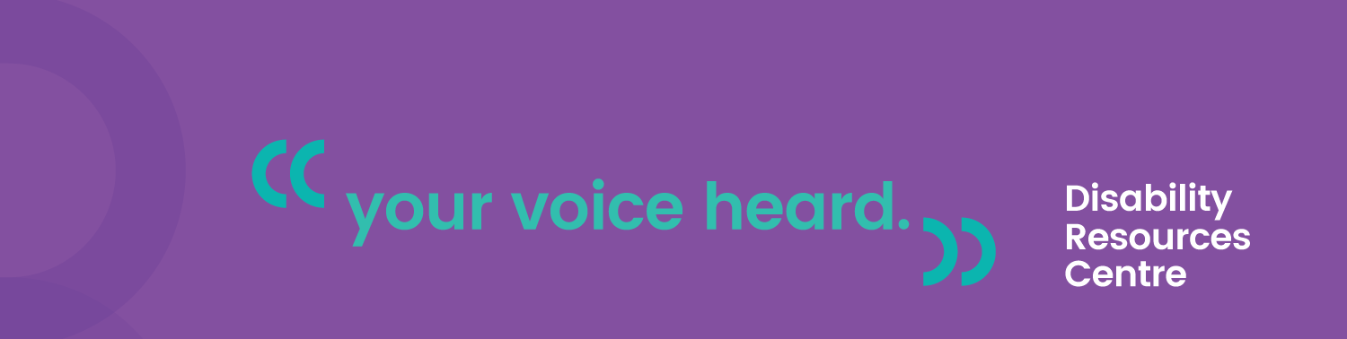
In one of the most quintessentially Melbourne articles ever written, TimeOut recently published a ranking of the city’s trams from 1-8, according to comfort, speed and aesthetic. Fun reading? Sure! Relatable? Probably – unless you’re one of the 838,000+ Melbournians who live with a physical disability.
For reference, that’s 17%. Or 1 in 6, if you prefer fractions. Basically lots of people, and by people we mean us.
With this in mind, it seems obvious that this ranking system didn’t account for one of the biggest flaws in our city’s tram network: accessibility. So we thought we’d offer a second ranking, from the perspective of Melbournians with physical disability. To mix it up, we’ll start with the worst.
W-Class
Accessibility ranking: 8
The W-Class reminds us of an out-house toilet. It’s a quaint and cheerful reminder of a time gone-by. Fun to look at, but we wouldn’t want to use one. Also like out-houses: most of us can’t use them anyway. The steps are way too steep, the doors are too narrow and the seats are about as comfortable as a pincushion. But it’s pretty, we guess?
A, B and Z-Class
Accessible ranking: 5-7
Z-Class trams may have the most comfortable seats, but that’s of little consequence if you can’t get on them to begin with. Or if those large, steep steps cause a pain flare-up that will haunt you for days. Or if the descriptions aren’t working and you can’t find a friendly co-commuter to tell you where you are. Or if the only clear space for you to put your mobility aid or Assistance Dog is in an aisle, in everyone’s way. We lumped these three together because when it comes to accessibility, they’re more or less the same: an epic fail.
D- Class
Accessible ranking: 4
Originally ranked as Melbourne’s worst tram, this gets 4th place from us as it’s one of the four trams people in wheelchairs can actually use. At all. The huge white bulks by the doors that serve no discernible purpose are in fact the tram’s wheels. It’s an inelegant use of precious seat space, and seats are extra precious to people with chronic pain and mobility challenges. But at least you can get on it without packing up your mobility aid or busting a hip on the stairs. So yeah, 4th place it is.
C2- Class
Accessible ranking: 3
Another low-floor tram with wide doors, designated accessible seats and wheelchair spots. Sadly, C2-Class trams are known to sway and stop abruptly. This increases the risk of injury to all passengers, and for people with disabilities that risk is higher to begin with. Many conditions also limit a person’s ability to grip poles or hand holds without pain, meaning a tram with no seats available = the danger zone.
Fun(?) fact: During peak hour, a person with a disability can watch 3-4 trams go by before seeing one they can board safely.
C- Class
Accessible ranking: 2
Step-free entry, comfy seats, wide lanes and high-capacity for all those commuters. Tick, tick, tick, tick. But like its C2-class cousin, the C sways, creaks and stops abruptly. Audio and visual descriptions are intermittent, meaning you better know where you’re going if you’re low vision or hard of hearing.
E-Class
Accessible ranking: 1
On this one, we can all agree: the E-Class is where it’s at. Low-floor trams that are wheel-friendly and don’t require the navigation of steps? Detailed automatic passenger announcements that are crucial for people who are low vision or hard of hearing? Brilliant! Still, only 30% of tram stops are adjusted to align with the tram floor, so if you can’t use a step, there’s no guarantee you’ll be able to get out when you need to. Turns out the best of the bunch still gets it wrong 70% of the time.
Fun(?) Fact: The E-Class is the first (and only) tram to comply with the Australian Disability Discrimination Act. The first article gave it “extra points” for this, but we’d say adhering to Human Rights Law is pretty pass/fail.

© Anja Homburg 2019 for Disability Resources Centre

