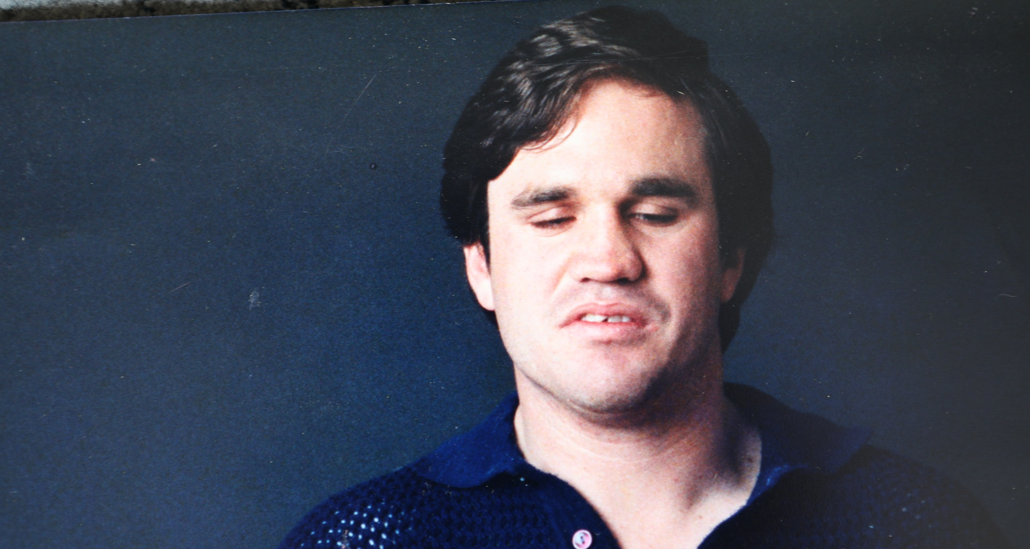
From Anger to Acumen: the Activism of Martin Stewart
For many years, Martin Stewart was driven by anger. It’s an understandable stance. Blind from birth, his childhood was marred by abuse, his education limited by abelism, and his early working life characterised by low wages and poor conditions. Under the circumstances, anger seems an entirely appropriate emotion to be carrying around. It was also powerful. Martin’s indignation in the face of injustice drove him to be one of the state’s most effective disability activists.
But one day in the 1980s while rolling headfirst down a flight of stairs, Martin began to wonder if his anger was serving him, or indeed, his cause. He had met a friend at the Royal Victorian Institute for the Blind for lunch. Assuming he was there to make trouble, the Institute had the police escort him from the premises. Officers shoved him down a flight of stairs, one of them shouting “Bloody Ghandi!” after him. “Which I regarded as a very high compliment” he says “And I told them so as I was rolling.”
He laughs at the memory. Then his face changes as he recalls the realisation that landed with him at the base of the stairs. “I thought, ‘Ok, we’ve got an issue here. There’s an obvious view that I’m always fighting, that I would never just be out for lunch with a friend… I’ve got to try and change people’s view of me.’” It was a moment of self-reflection that would transform Martin’s career. He sought out the help of an influential friend (World Blind Union President David Blyth) learnt to be more diplomatic in his approach and eventually gained the ears of people who had once considered him an adversary.
He gained more than their ears. Martin would sit on the Victorian Institute for the Blind’s Conciliation Group, then its industrial board. “I sat on the very board tables that used to sit against me,” he says, “You can, without selling out, persist with the same viewpoints but calibrate your language and posture in order to get acceptance.” He became so well respected among both activists and institutions that he was named 2018 Blind Australian of the Year.
The transformation that led to this accolade was remarkable, but unsurprisingly it was neither quick nor painless. It began when Martin moved to Melbourne from his native Sydney and started working for the Royal Victorian Institute for the Blind (RVIB). His arrival there would spark one of the country’s most well-known workers’ rights movements: the right for people with disabilities working in sheltered workshops to be given fair wages, complaints mechanisms and proper treatment. Even RVIB’s own history acknowledges his influence, saying “It is difficult to tell whether anything would have occurred if Martin Stewart had not started to work at the factory in June 1985.”
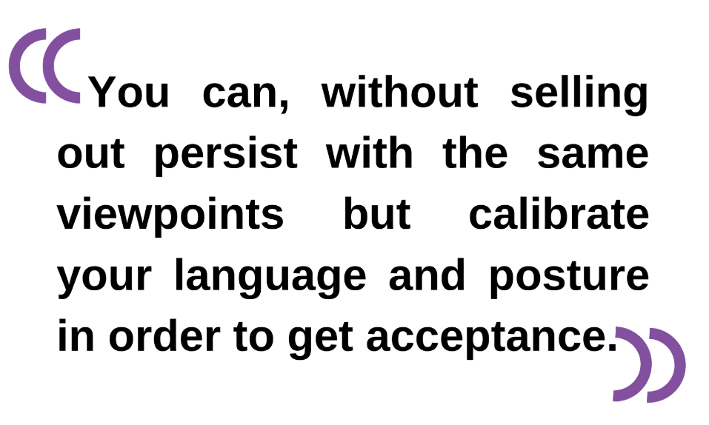
At first, Stewart wasn’t sure if his concerns were justified. He felt the wages at the factory were unfairly low, the conditions poor and the absence of a complaints mechanisms worrying. “But it was after speaking to other workers that I knew something had to be done. This was affecting all workers. (We) Set about forming a collective and had a meeting… and the rest is history. Good history.” He says.
That history can be found in The Age newspaper archives from July to December 1985 (yes, July – only a month after Martin began working at RVIB – the man wastes no time). Martin and others formed People for Equality Not Institutionalisation (PENI) and staged several protests over the coming months. They once broke into the RVIB Executive Director’s Office to stage a sit-in, and eventually joined forces with the Blind Workers Union to stage multiple strikes for fair wages.
In November 1985, the final strike ended when a government-appointed arbitrator found in favour of the Union, requiring RVIB to pay full pay indexation to all employees backdating to 1983. That very same month, Tony Lawson’s report about PENI’s grievances relating to RVIB was published. The report seconded PENI’s calls for an independent hotline for people with disabilities wanting to complain about service providers, and an enforceable code of conduct guiding the fundraising practices of charities. “Because of the heavy dependency which people with disabilities have upon service providers like the RVIB, I believe the consumer doubts about the efficacy and independence of in-house complaints and appeals procedures are justified.” Lawson said.“We did a lot of celebrating (that month),” Martin recalls with a smile. The movement that sprung out of issues at RVIB set the stage for a transformation in disability law and marked the beginning of the end of institutionalisation as the dominant model for disability service in Australia.
Given the challenging new era his employment ushered in, and his tendency to break into the offices of senior staff, it’s not surprising that the heads of RVIB were reluctant to believe Martin Stewart was only on the premises for lunch with a friend. When he found himself on the bottom of the stairs that day, he was confronted by the downside of his anger. He and PENI had achieved a great deal through it, but how much more was he going to be able to influence if this was the reception he received?
It wasn’t just institutions like RVIB who struggled with him. At one point, a group of blind people congregated at Ormond Hall in Prahran to oppose Martin’s protest style. “On reflection, they were probably right,” he says “Not (about) my message, but my ways were wrong. I would be shouting all the time, using aggression and although I felt angry, if I’d been wise I would have been able to say exactly the same things but in a different way.
“I used to be so determined about things. I wasn’t a good listener.”
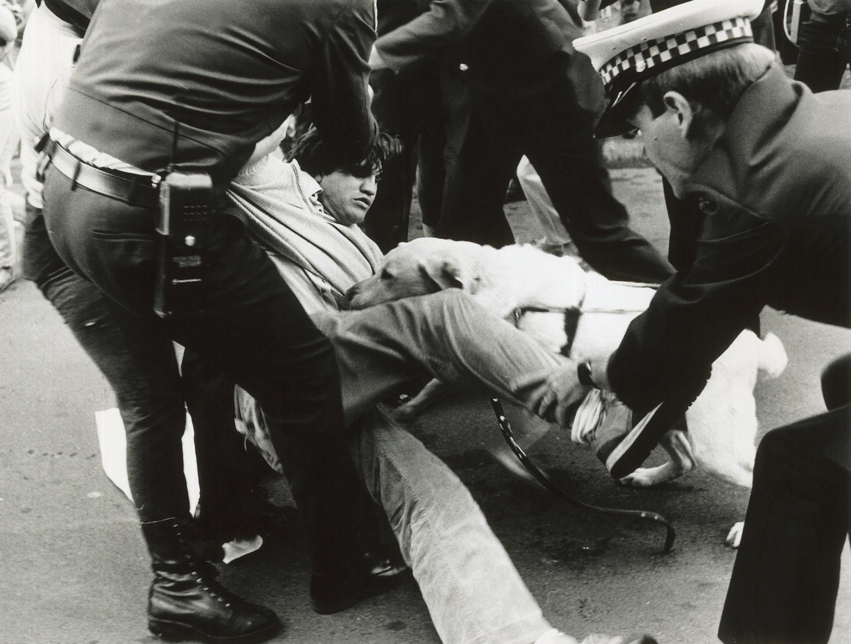
So he started to listen, and learn. With guidance from trusted friends, and a stalwart commitment to the “process of persuasion”, Martin slowly transformed his reputation. He began working with organisations, instead of against them, to incite change. “It’s no good talking about inclusion if you don’t include even those that are upsetting you in your approach,” he reflects. Over time, this shift in manner would lead Martin Stewart to sit on boards of organisations, like RVIB, who once called the police on him.
Martin’s guide dog tries to stay close as police remove Martin from the Miss Victoria Protest. Photo: Wayne Ludbey/The Age
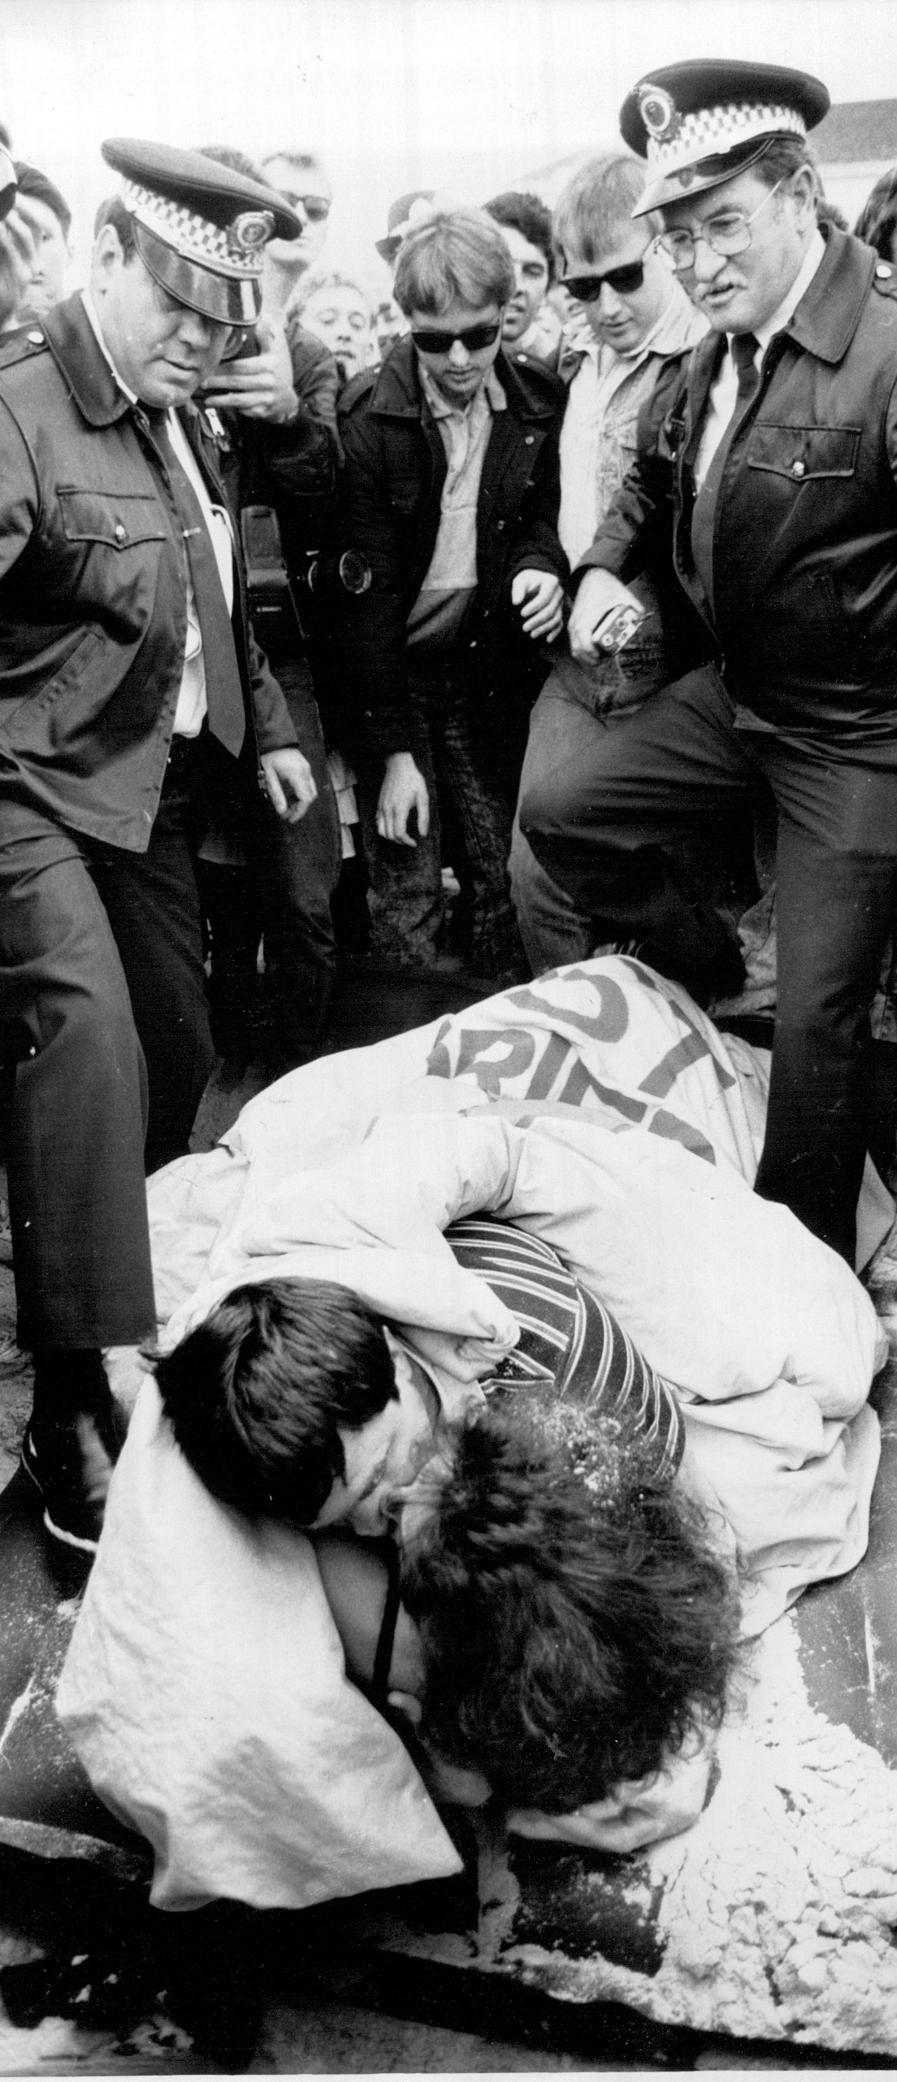
This is not to say that his newfound approach meant he abandoned protest entirely. In the years that followed Martin continued to use direct action to make important points. In November of 1986, Martin was among those arrested for protesting the Miss Victoria Pageant. Less than two years later, he married fellow activist Helen Said, and the couple staged their honeymoon on Bondi Beach to raise awareness of the sexual rights of people with disabilities.
Police prepare to arrest Martin and Helen Stewart during their ‘Honeymoon Protest’ on Bondi Beach. Photo Michael Rayner/The Sydney Morning Herald
Martin and Helen were frustrated by people with disabilities being seen almost exclusively as the recipients of charity, care and love. “We decided to get married and make it a public event because we can give, including giving love,” Martin says. The couple placed a flag on the beach that read ‘Sexual equality for disabled people worldwide’. Martin gave out money to passers-by to demonstrate a person with disability’s capacity to give charity as well as receive it. Then the pair got under a sheet atop a blow-up mattress and began “doing what many people do on honeymoons.”
They drew a crowd of about 300 and were arrested for attempting to make love in a public place. “They (the police) were good, there’s no doubt about it. They did what they felt they had to do, and we were doing what we felt was necessary to draw attention to a social cause.” And attention they drew. The couple were invited to speak at universities and other educational institutions across the country in the wake of their protest.
Another area Martin has always been passionate about is the accessibility of public transport. He vehemently opposed the removal of guards and platform attendants from trains and stations, warning that their absence increased the risk of injury to blind and low-vision passengers. In particular, the gaps between train carriages could easily be mistaken for open doors. Eventually, he said, someone was going to be seriously injured or killed. No one expected that someone to be Martin himself.
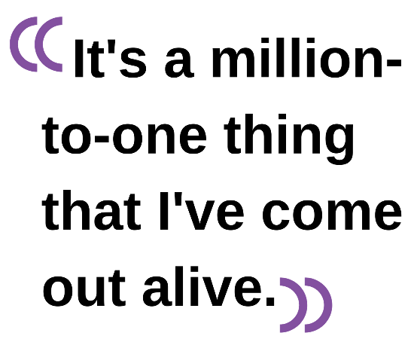
On an afternoon in 2002, he was at Richmond station heading home from his job as a disability advocate. The audio announcements weren’t working properly, and he was distracted. Just as he predicted someone would, Martin mistook the gap between the carriages for a doorway and fell onto the tracks.
An onlooker tried desperately to get the driver’s attention, but the train took off and dragged Martin 200 metres before speeding away. His right arm and the bottom half of his right leg were torn off.
He calls the event his “lucky day”. If there hadn’t been someone trained in first aid on the platform to stop the bleeding, he would not have survived. “It’s a million-to-one thing that I’ve come out alive,” he says.
Luck aside, the accident took a toll on Martin and his young family (his son was three, his daughter seven months at the time of the accident). For a long time he wasn’t able to help around the home, and the rehabilitation was arduous. “I never felt blind until I had my accident,” he says, but the loss of his dominant right hand meant he had to re-learn how to navigate his environment.
Still, Martin was adamant that he was done giving way to anger. “You can easily fall into wallowing about your own circumstance. I made a very clear decision not to… overall I see myself as fortunate to have gained this knowledge. I have the lived experience of being in a wheelchair, as well as total blindness. Out of that I have broadened my advocacy horizons. Now there are gap fillers being produced on Victoria’s train system to prevent accidents like mine.”
Martin currently works as an Advocacy Officer for Blind Citizens Australia, and continues to advocate for accessibility in sporting apps and on public transport. His most recent victory was using his accident to persuade NSW Transport Minister Andrew Constance not to remove train guards from the newest fleet of intercity trains. The Minister agreed that the safety of passengers could not be put at risk, and stood alongside Martin when he announced his decision to the press. “That was a good moment,” Martin reflects, with the slightest hint of disbelief in his voice, “I want to be someone that people have benefited from.”
With thousands of lives transformed by his work, Martin Stewart could declare that mission accomplished. But he won’t. A man courageous enough to face the downsides of his own anger isn’t likely to stop improving the world, or himself. Lucky for us.
© Anja Homburg for the Disability Resources Centre 2020.

Buckrich, Judith R. 2004. A History of the Royal Victorian Institute for the Blind 1866-2004. Melbourne. Australian Scholarly Publishing.
Robinson, Paul. 1985. Pay win jeopardises blind services, says director. The Age. 30 November. Page 6.
Best, Bruce. 1985. Report supports complaints hotline for the disabled. The Age. 9 November. Page 4.
Ibid.
The Age. 2002. The blind prophet who fell victim to his own predictions. April 22.

