VOICES
THE DRC ADVOCACY NEWSLETTER

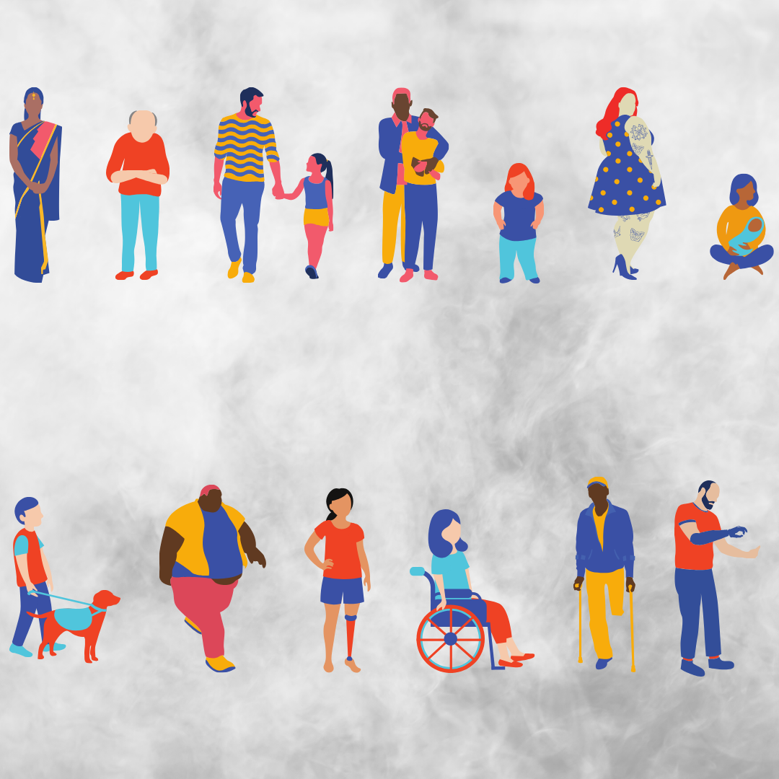

BE EMERGENCY READY EVERYONE NEEDS A PLAN

EMERGENCY PREPAREDNESS
A disability-led planning process | 07

TRANSPORT CAMPAIGN GOES REGIONAL
Events happening across Victoria | 03

REMEMBERING LESLEY HALL
An icon of the Australian disability movement | 06

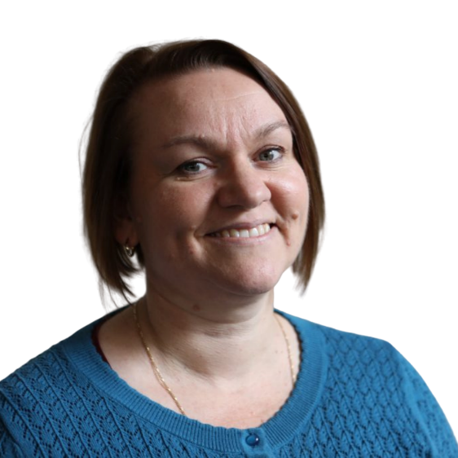

WELCOME TO THE SUMMER EDITION OF VOICES
Front of mind for many of us over recent weeks has been the impact of extreme weather events and bushfires. This is personal to me as my family live in a fire-prone area. A few years ago, at a point when my disability prevented me from driving, we were told to evacuate. I felt extremely vulnerable in the face of it all, and was lucky that a family member was available to collect my children and me and take us somewhere safe.

It is so important that we regularly review our emergency plans and ensure that we have supports in place should we be affected by a natural hazard emergency. Even if it doesn’t happen to us directly, watching what is happening to others and to our wildlife can be stressful. Practicing self-care and looking after our mental health is vital. Disaster readiness was a topic raised at last year’s AGM and is something our staff and Committee of Management will focus on more throughout 2020.

Last December I was interviewed on ABC Radio National along with a spokesperson from the climate activist group Extinction Rebellion. While the focus of the interview was the impact of protest on people with disabilities, it was important to let the public know that extreme weather events impact people with disabilities more acutely. It was also an opportunity to remind the community that people with disabilities can and want to be part of demonstrations for social causes, as evidenced by the DRC’s own rich history.

Our individual advocacy program has received a well-earned boost this year with an increase in our core funding from February 2020. This reflects the great work our individual advocates do, supporting people to know their rights and partnering with them to see those rights obtained, as well as building clients' self-advocacy skills in the process.

Accessible Transport continues to be a strong focus this year, with transport campaign workshops coming up across regional Victoria. Each workshop will include presentations and skill-building sessions around how individuals can use their stories to push for social change. Finally, participants will come together to plan fun and effective direct actions to further amplify the message that accessible transport is a fundamental right for everyone.

We were also thrilled to learn late last year that we have received an Individual Capacity Building grant through the NDIS to focus on pathways for young people to be involved with the DRC. We are in the early stages of developing this program and look forward to telling you more about it in the coming months.

Happy New Year. May it be safe and enjoyable for each of you.

Kerri Cassidy – Executive Director

SKILL UP AND CAMPAIGN TO MAKE OUR PUBLIC TRANSPORT SYSTEM ACCESSIBLE TO ALL

The Disability Resources Centre is running a series of free, one-day workshops to bring together people who want to change the Victorian transport system for the better. These will be held in Sale, Traralgon, Geelong, Warrnambool, Ballarat, Shepparton and Melbourne. Together we will learn about the different ways we can use our voices and our experiences to affect social change and plan effective campaigns. You can sign up to attend these events by clicking the town name below, or by contacting Ally Scott: ally@drc.org.au, 0452 124 844, 03 9671 3000.

Sale
3 March, 10am – 4pm
Venue TBC

Melbourne
8 April, 10am – 4pm
Ross House Association
247-251 Flinders Lane
Taralgon
4 March, 10am – 4pm
Taralgon Library
34 Kay St

Warrnambool
18 March, 10am – 4pm
Archie Graham Community Centre
118 Timo St
Geelong
10 March, 10am – 4pm
Venue TBC

Wodonga
2 April, 10am – 4pm
Venue TBC
Shepparton
1 April, 10am – 4pm
Venue TBC
Ballarat
25 March, 10am – 4pm
Ballarat Town Hall
225 Sturt St

AGM 2019

Our Annual General Meeting was a great chance for members to come together, learn
and usher in another year of advocacy for DRC.

DRC finished a busy and successful 2019 with its AGM on 25 November. With 29 in attendance, it was wonderful to see so many people come along to usher in the new Committee of Management, find out what DRC is up to, and take part in highly fruitful discussions. DRC welcomed Mary Henley-Collopy on as the new Chairperson for 2020, as well as many of the board’s pre-existing members. Following the AGM itself, guests were treated to a presentation by the advocate Jody Barney. Jody shared the story of her unique upbringing as a Deaf Aboriginal woman and how those experiences inform her work as an advocate in Aboriginal communities. Julie McNally gave an update on her work on the Royal Commission, and Ally Scott spoke about the Transport for All campaign. Finally, members formed groups and answered questions about DRC’s work and the individual experiences, both good and bad, that they’d had in the community. We thank everyone for their involvement and enthusiasm, and look forward to more time with each of you in 2020.
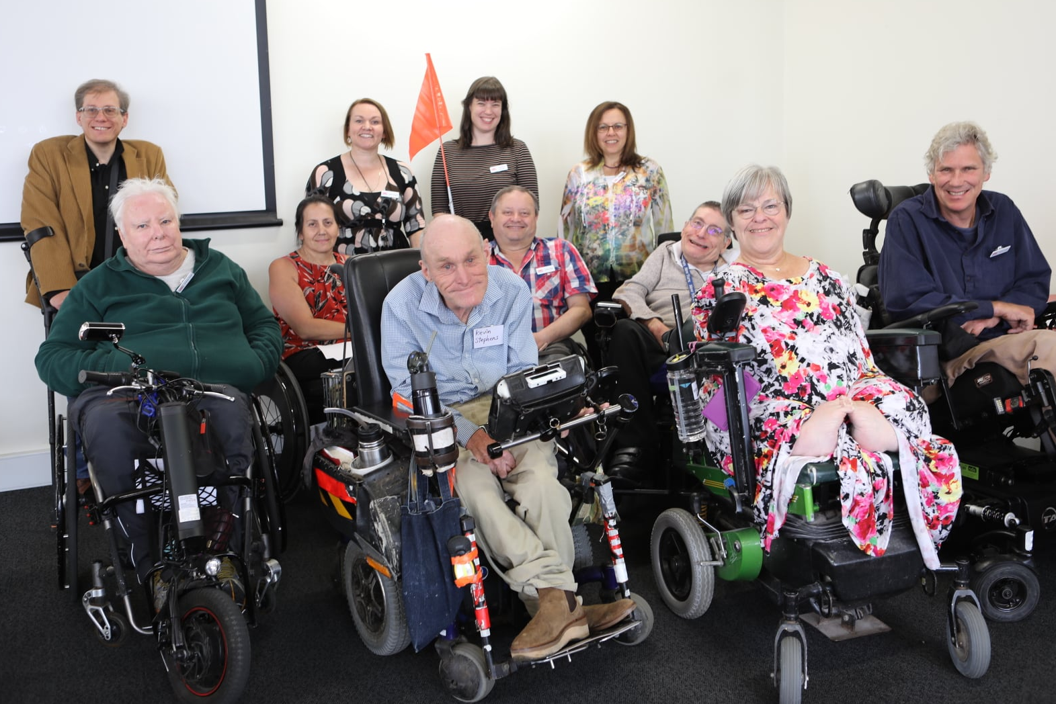

Accessibility & Disability Forum on Public Transport

Executive Officer Kerri Cassidy gave a presentation on DRC's 'Transport for All' Report at the Investment Centre on 2 December, 2019.

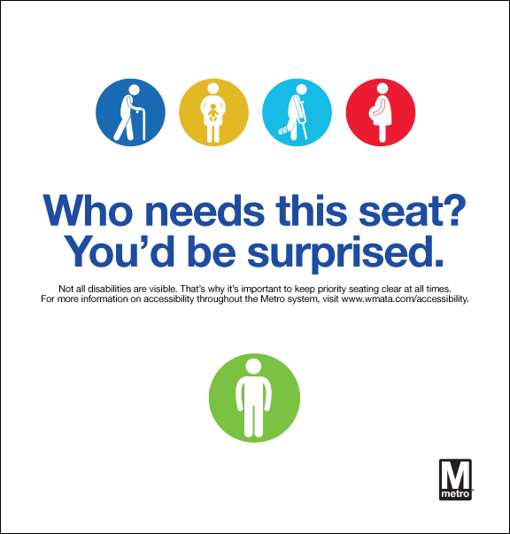
Disability Resources Centre is a member of the Accessibility and Disability Forum - a newly created working group with representatives from various government and non- government organisations, including the Department of Transport, Commercial Passenger Vehicles Victoria, VCOSS, Victoria Police, and the Disability Services Commission. The group exists to foster dialogue about inaccessible transport between users, transport operators and government, with the aim of finding solutions to what people with disabilities identify as the major barriers to equal access in the Victorian transport system.
Kerri presented to the forum on the findings of our Transport for All research project and the progress of our current Accessible Transport Campaign. The presentation used the real experiences of members, accompanied by photographs, to put a human face to the issue of inaccessible public transport. Kerri told stories of steep ramps, dangerous platforms, overcrowded trains and a mismatch between accessible trams and accessible stops. Forum members said that despite knowing Victoria’s transport system needs massive improvements, seeing the human impact of inaccessibility made it feel real and urgent.
We need to keep talking about these problems and ensuring that people’s stories are told and heard. We hope to hear more from this group throughout 2020, and look forward to the recommendations they will make to move Victoria closer to meeting the Disability Standards for Accessible Public Transport.

REMEMBERING LESLEY HALL

The year is 1981. International Year of Disabled Persons. The St Kilda Town Hall is hosting the annual Miss Victoria Quest, a beauty pageant raising funds for the then-named Spastic Society.
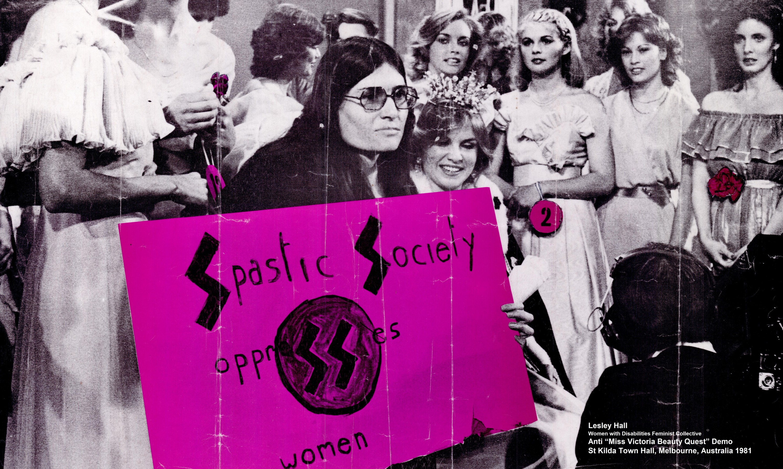
A long line of white, slender, able-bodied women occupy the stage. Their forms are pristine, embodying the Western obsession with female youth, health and beauty. They are also a stark contrast from the people this pageant is meant to support: those living with cerebral palsy, whose bodies rarely conform to the rigid standards of a beauty contest. Which is fine, since no such people are present. Or aren’t they? The young Lesley Hall, while not living with cerebral palsy, has a rare condition that limits her mobility. Incensed by the hypocrisy of the pageant and the Spastic Society’s collusion with standards that make life harder for people with disabilities, she takes to the stage. The pageant’s winner has just been crowned, but the limelight isn’t hers for long. Lesley places herself in front of the beauty queen, holding a placard that reads “Spastic Society oppresses women”: able-bodied women by exploiting their bodies and limiting their value to aesthetics; disabled women by relegating them to the sidelines, diminishing their capability by silencing them. The women around her are stunned, but Lesley holds fast, determined to make her point. A photographer seizes the moment, taking a picture that will become as iconic as the woman it features. Lesley Hall devoted her life to disability advocacy, founding DRC Advocacy the same year she staged this protest. Her photograph hangs on our office wall, a reminder of what tenacity and courage can achieve. A large print of the image can be found on level 4 of Ross House, outside the DRC. More copies may be available on request.

This summer’s bushfires were a solemn reminder that natural disasters can strike with little warning,
DO YOUR HAVE AN
EMERGENCY PLAN?
and we all need to have a plan should things go wrong. Collaborating 4 Inclusion, along with Sydney University, is working to include people with disabilities in disaster risk management, and has
developed a model to help people set up emergency plans: Person-Centered Emergency Preparedness
(PCEP).

First, the PCEP asks you to think about 8 areas of life:

Living Situation
How many exits are there in your home? Do you have somewhere to go in an evacuation? Do you know where the nearest shelter is?

Health Management
Where is your health information? What are your nutrition needs? What medications do you take?

Transportation
How do you get around? Who helps you? How do you arrange transportation?

Social Connection
Who are your support people? Are they nearby or far away?
Who are the people you see regularly? Who relies on you for support?

Communication
How do you communicate with people? How do you seek out information? Do you use assistive technology?

Assistive Technology What devices, technology and equipment do you use? What power sources will you need? Who helps you with these devices?

Assistance Animals
What does your animal need to stay healthy? Who helps you care for them? What supplies does your animal need?

Personal Support
Who assists you with daily activities? What do they help with? How do you cope when they aren’t available?

Once you've considered your needs and capabilities, follow these 5 steps for Emergency Preparedness:

Know your local hazard risk
Do you live somewhere prone to flooding, bushfires or other natural hazard emergencies? Talk to your local council about your risk.

Make a plan
Plan for unexpected evacuations and needing to shelter in your home. Put together emergency kits for both scenarios. Write down your plan, share it with people who would help you and practice it at least once a year.

Get your home ready
Make sure your home is free of hazards that would make leaving quickly difficult.

Be aware
Identify sources you trust to get accurate information about disasters. Examples are the State Emergency Services Facebook page, the Bureau of Meteorology or your local ABC radio.

Look out for each other
Check in on friends, family and neighbours. Make sure others know about the risks and are prepared

More information:
For a more detailed look at Person-Centred Emergency Preparedness you can go to the Collaborating 4 Inclusion website here, or go to the User Guide. Pages 18-22 and 27-35 are particularly useful.

The Red Cross also has an emergency planning guide, RediPlan that you can consult here.

Reference
Villeneuve, M., Sterman, J., & Llewellyn, G.L. (2018). Person-Centred Emergency Preparedness: A process tool and framework for enabling disaster preparedness with people with chronic health conditions and disability. Centre for Disability, Research and Policy, University of Sydney, NSW 2006.

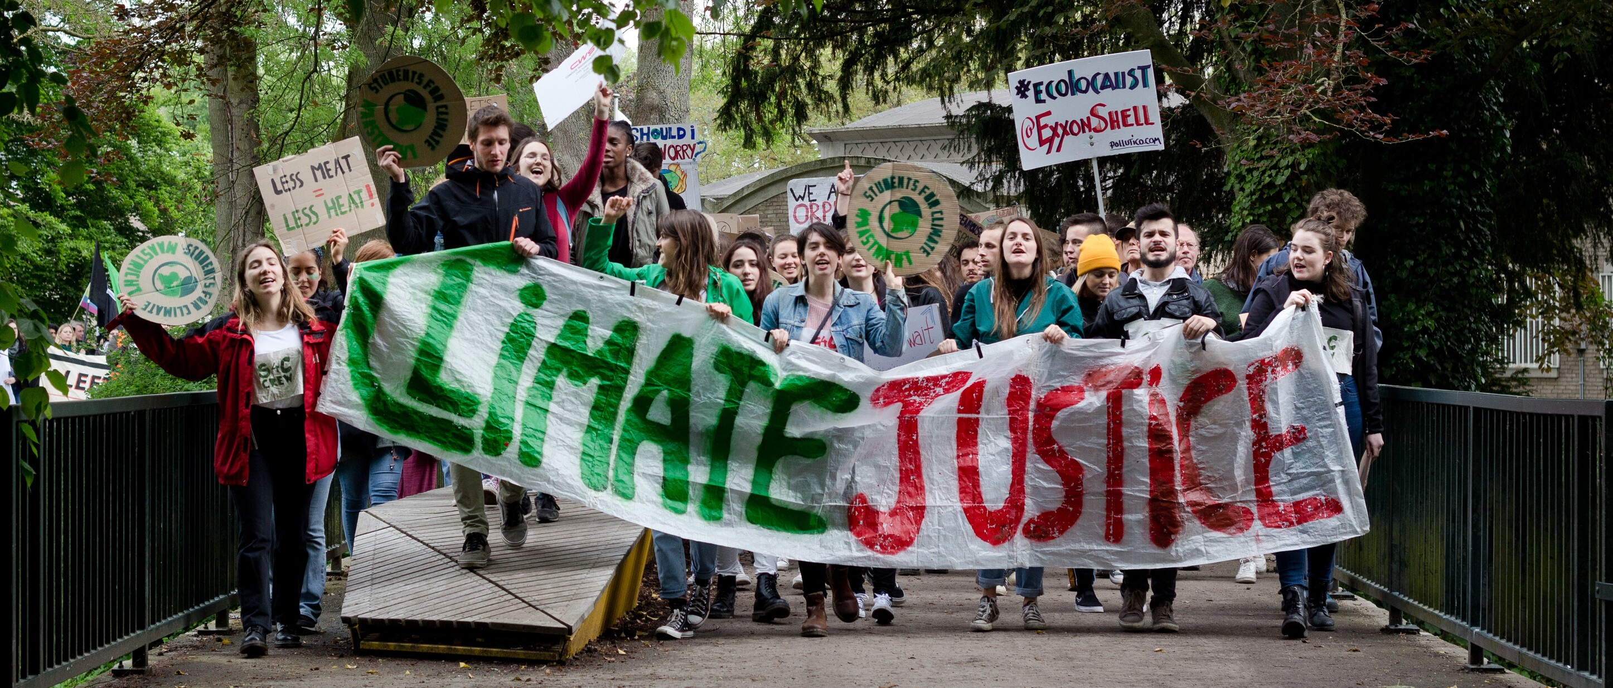
Kerri Cassidy speaks with Extinction Rebellion on ABC Radio National
Executive Director Kerri Cassidy was asked to speak on ABC Radio National’s show Drive on 10 October, after a man with mobility limitations alleged Extinction Rebellion (XR) protesters swore at him when he asked to get past their blockade. The incident sparked a national discussion about the unique impact of protesting on people with disabilities and the place of marginalised communities in protest movements. Kerri spoke to Patricia Karvelas about DRC’s own history of direct action and the disproportionate effect climate change will have on people with disabilities. “It’s also true that disruption affects different people differently,” she said, and groups like XR need to find ways to be disruptive without causing undue distress to individuals. Involving people with disabilities in the XR movement is the easiest way to ensure their next protest will be sensitive to accessibility issues. XR spokeswoman Reem Ramadan apologised on air to the man affected by the protest and said the group would reach out to the disability community to learn how to better meet their needs.
You can listen to the conversation by clicking here.

Stay in Touch
In addition to our regular newsletter, you can keep track of what we’re up to in real-time through our social media profiles. Follow us on Facebook and twitter @DRCadvocacy to get updates, fun features and a review of the latest disability-related news.
Want to receive Voices via email?
Just email anja@drc.org.au from your preferred address, or give us a call on 03 9671 3000.

