DRC
advocacy

Transport for All

Disability Resources Centre

Acknowledgements

The Disability Resources Centre (DRC) would like to acknowledge the hundreds of individuals with disability throughout Victoria for their participation and contributions to the project and the resulting report to government. Disability groups and organisations played an important role in promoting the multiple consultation strategies, and together with rural and metropolitan access workers and local government Disability Advisory Committees, ensured community consultation forums were accessible and inclusive.

DRC would also like to acknowledge core project funding provided by the Victorian Department of Health and Human Services through its Disability Advocacy Innovation Fund. Additional funding provided by the Reichstein Foundation enabled the project to provide two additional regional/rural forums and consider campaign implications moving forward.

We acknowledge the traditional owners of country and pay our respects to Elders past, present and emerging.

Table of Contents
Acknowledgements 2
Executive summary 4
Context 4
The project 5
Findings 5
Key factors affecting accessibility 6
Conclusion 8
Recommendations 8
Introduction 10
About the Project 10
Context 11
Research methodology 15
Findings 17
Overview of Consultations 17
Online Survey 17
Forums 19
Interviews 20
Key factors affecting accessibility 21
Conclusion 28
Recommendations 29

Executive summary

The Disability Resources Centre Inc. (DRC) is a statewide Disabled Peoples’ Organisation which was formed in 1981. DRC is a membership-driven organisation managed and staffed by people with disabilities. Membership of the DRC is free, and people with disabilities are encouraged to join. In addition to its metropolitan individual advocacy program DRC also prioritises system advocacy. DRC’s systemic advocacy is focused on ensuring that people with disabilities have a voice that is heard, and advocates for change to achieve equity.

Context

Australia became a signatory to the United Nations Convention on the Rights of Persons with Disabilities (CRPD) in 2008. The National Disability Standards for Accessible Transport in Australia (Transport Standards) were introduced in 2002 and are one means to help to ensure that Australia meets its international obligations under the CRPD. The National Disability Strategy 2010-2020 (NDS) was launched in 2011. The NDS translates the principles underpinning the CRPD into the government’s policies and programs directed towards people with disability. The NDS Policy Direction 4 of Outcome 1 focuses on developing a public, private and community transport system that is accessible to the whole community. The NDS identifies accessible public transport as a key factor in the capacity of a person with disabilities to participate in, and contribute to, society and the economy. The Transport Standards operate under the Commonwealth Disability Discrimination Act 1992 (DDA).

The Victorian Government’s State Disability Plan 2017-2020, Absolutely Everyone, describes accessible public transport, including Commercial Passenger Vehicles as a “critical” means to access education, employment and social activities for people with disabilities. In 2013 the Victorian Human Rights and Equal Opportunity Commission noted that “significant barriers” remain in place for people with disabilities using public transport in Victoria.

To date there have been two reviews of the Standards in 2007 and 2012, with a third in 2017 rescheduled to 2018. In its submission to the second review of the Standards in 2012, the Victorian Department of Transport’s submission noted that while the 2012 compliance targets had generally been met, some had not. For example, in relation to the accessibility of trams compliance was 23% rather than the target of 55%. In reference to trams it indicated that these have a replacement cycle of 30 years, that older stock could not be retrofitted and that Victoria was likely to experience difficulty meeting some of the December 2017 targets calling for public transport systems to be 80% or 90% accessible. However, Victoria did indicate its commitment to a program of ongoing improvements to accessibility across its public transport system and its goal of achieving 100% compliance by 2032. The Review did acknowledge that most states and territories felt that significant additional resources would be required to meet the compliance targets for December 2017 and December 2022.

The project

The DRC’s Accessible Public Transport Project was developed in response to ongoing accessibility barriers within the Victorian public transport system. The primary purpose of the project was to explore the experiences of Victorians with disabilities in using, or trying to use, public transport and Commercial Passenger Vehicles (taxi and rideshare) within the state. Multi-pronged consultation strategies were used to gain an insight into:

- what is working, and/or not working;
- what needs to be introduced to improve accessibility, and
- what the impacts of an inaccessible public transport system are on the lives of people with disabilities.

In order to reach a diverse audience, and to cater for individuals with various accessibility needs, three consultation strategies were devised. The project developed an online survey for those unable to attend public forums for whatever reason, held 5 consultation forums in Melbourne, Dandenong, Shepparton, Ballarat and Sale, and conducted a number of one to one interviews to capture more in-depth experiences of individuals with a disability. The Australia Government’s The Whole Journey- A guide for thinking beyond compliance to create accessible public transport journeys provided a useful framework to guide the consultation questions.

Funding from the Victorian Department of Health and Human Services’ Disability Advocacy Innovation Fund provided one off funds to recruit and employ a part-time project officer, conduct three metropolitan and outer metropolitan/regional consultation forums, develop an online survey and provide a written report to government. Additional funding provided by the Reichstein Foundation’s Small Grants program enabled the project to provide two additional regional/rural forums and to consider campaign implications moving forward.

Findings

The DRC consulted with more than 450 individuals with disabilities throughout Victoria in the latter part of 2017 through to May 2018. Participants in these consultations represented a diverse range of disabilities, age groupings and metropolitan, regional and rural locations within the state. Participants represented a variety of factors affected by disability including people with vision impairment, hearing impairment, wheelchair users, those living with chronic illness and those with communication difficulties. Participants responded with goodwill, honesty and a genuine desire to be involved in creating solutions.

As many people noted, an affordable and accessible public transport system was integral to their independence and the extent to which they could pursue the opportunities many others in the community took for granted. This included study, work, recreation and social and civic participation. People were quick to point out the benefits of an accessible public transport system for many others in the community. This includes those who are elderly, travelling with children or luggage, pram or shopping buggy users and people with a temporary condition, as well as people with disabilities.

Key factors affecting accessibility

Several themes developed throughout the consultation process, some were widespread across the network and others were confined to the location or mode of transport.

Barriers which were consistent throughout Victoria and affecting all modes of transport related to the provision of travel information, priority seating and parking, public attitudes and personal safety, transport staff conduct and community consultation. Participants with vision or hearing impairments in particular noted the difficulty in finding reliable information whilst using public transport and noted that when a change to a service occurs, the information provided is slow to react, if at all. Whilst most public transport provides priority seating it is not always made available to those who need it, as experienced by several people with impaired mobility which was both obvious and invisible. These poor public attitudes extended to harassment, abuse and in some cases assault, leaving many feeling unsafe and vulnerable. People also reported feeling unsafe when navigating physical spaces due to overcrowding, lack of seating and poor lighting at night. It was commonly reported that people have felt disrespected or assisted inappropriately by transport staff across all modes of transport. There was a general sense that there were few opportunities to provide feedback to transport operators about accessibility issues, and a lack of transparency about ongoing developments. One exception identified was the new High Capacity Metro Train consultations.

Issues specific to modes of transport are discussed throughout the report including bus safety, tram boarding, access to train platforms and barriers associated with Commercial Passenger Vehicles. Concern with bus safety extended beyond the boarding and disembarking from the vehicle to include insufficient time given for passengers to safely be seated and drivers accelerating, braking and taking corners dangerously.

The ability for individuals to board trains, trams and buses without assistance is an important aspect of independent travel and inclusion in society. Participants reported that train platforms that enable them to roll on and roll off without the need for a portable ramp are now available at several stations. The additional benefit of these stations is the reduction in dangerous gaps and steps between the train and the platform which benefits people will disability of all types. Whilst a positive development, updating all stations throughout the Metro and V/Line services is required for full accessibility.

Trams are not only used by those living in the Metropolitan area, but by those who travel to Melbourne to access services and cultural events. When low floor trams are consistently and predictably matched with accessible stops, independent boarding for wheelchair users and those who have trouble taking steps is enabled. Likewise buses with ramps that are operated safely with accessible stops and/or curbs are used effectively by people using mobility aids. Participants generally agreed that they would use more public transport if they felt assured that all modes of transport allowed independent access and was reliable across every service.

Wheelchair Accessible Vehicles (WAV) and regular Commercial Passenger Vehicles (CPVs) are used by many as their only mode of transport, especially those in rural areas where there are no other forms of transport, and for those who find other modes of transport either time consuming, unreliable or they are not confident to travel alone. It is however an expensive way to travel, even for individuals with an Multi Purpose Taxi Program (MPTP) card. Rideshare options were not used by many people who participated in the Project. Reasons given were that accessible services such as Uber Assist, intended to cater for people with disabilities, rarely has cars available when needed and people did not feel that the drivers were adequately trained or regulated.

Barriers to public transport access identified in metropolitan areas are amplified in rural and regional locations, with the additional reality that there are fewer services available. Transport options tend to relate to travel from regional areas to Melbourne, or from more remote areas into the regional centres. There are limited services between towns and it was common for transport to be prioritised for school transport taking buses and CPVs out of circulation for several hours of the day and therefore limiting choice and flexibility. Travellers Aid was applauded by participants who had used the service upon arriving in Melbourne, and there is a strong desire to see this service expanded into key regional centres.

The impact of inaccessible transport is considerable providing a barrier to employment, study, social and civic life as well as the ability to enjoy independent travel and making choices as the general population does. A negative experience such as abuse or being stranded can lead to avoidance of public transport resulting in isolation and inability to take up opportunities that are available in the community.

Conclusion

The direct lived experience of individuals with disabilities formed the primary database for the project, and analysis of the collated data informs the findings, conclusions and recommendations of this report.
While many people with disabilities were able to deal with most challenges of public transport, the majority of participants in the consultations expressed concerns and anxiety about trying to use the transport system. For some, the lack of an accessible transport system meant they were forced to rely on the goodwill of family or friends where these existed; for others it resulted in social isolation, a loss of independence and an inability to pursue the opportunities offered in the community.

There were multiple factors cited by participants about what was not working in the public transport system. These could generally be classified as a lack of genuine consultation with people with disabilities, attitudinal and behavioural problems of staff and/or the public, physical barriers including inadequate and inaccessible information systems, a lack of planning and public amenity and an absence of continuous quality improvement monitoring and review. The majority of respondents who faced challenges in the public transport system often experienced more than one of these barriers to a safe, accessible journey.
The findings of this report indicate that there is still considerable work to be done to develop an accessible system of public transport in Victoria. The Transport for All report asks planners, engineers, providers, government funders and others to see the journey through the eyes of the traveller; that is the individual with disabilities. This report has consulted widely to capture and share the experiences, both positive and negative, of the public transport system through the eyes of Victorians with a disability and to identify strategies to move to a fully accessible public transport system.

Recommendations

Based on the findings and conclusions of this project it is recommended that:

- The Public Transport Access Committee (PTAC) include regular representation by key Disability Advocacy Groups who have the opportunity to advise the Minister on Public Transport accessibility matters.

- Public Transport Victoria and Commercial Passenger Vehicles Victoria establish a program of ongoing consultation with people with disabilities and key disability advocacy organisations to plan, implement and review the development of accessible public transport in Victoria.

- In consulting with people with disabilities, multi modes of engagement and communication are utilised to enable meaningful participation.

- In collaboration with a key disability resource and training organisation, a comprehensive disability education and training program be developed for all public transport providers in Victoria. Successful completion of this training should be a pre-requisite for all staff prior to any roles and responsibilities related to working with the public.

- 100% completion of the disability education and training program for all staff dealing with the public becomes a Key Performance Indicator (KPI) for government public transport provider contracts and an ongoing registration requirement for Commercial Vehicle Provider operators.

- A multi-media community education program be conducted to raise awareness about the diverse nature of disability, the critical role of accessible public transport for the study, work and life aspirations of people with disabilities, and to highlight the key components of accessibility in daily public transport.
- The Victorian Government develop and publish its forward plan detailing the steps, key milestones, timelines and key performance indicators to deliver a fully accessible public transport system which complies with the Disability Standards for Accessible Public Transport (DSAPT) by 2032.

- A Public Transport Feedback and Complaints Register (PTFCR) for all modes of public transport be established to promote accountability, transparency and continuous quality improvement. The PTFCR be managed by the Public Transport Ombudsman and include the production of annual audit reports identifying the nature and category of complaints, and the outcome and timeline for resolution of all complaints.

Introduction

The Disability Resources Centre Inc. (DRC) is a Disabled Peoples’ Organisation which was formed in 1981. DRC is a membership-driven organisation managed and staffed by people with disabilities. Membership of the DRC is free, and people with disabilities are encouraged to join.

DRC champions the principles and rights articulated in the United Nations Convention on the Rights of Persons with Disabilities (2006). Alongside our metropolitan individual advocacy program, we also prioritise systemic issues, working for long-term social change to ensure the collective rights and interests of people with disability are served through legislation, policies, services and practices in our community. Our systemic advocacy is focused on ensuring that people with disabilities have a voice that is heard, and advocates for change to achieve equity. Our systemic advocacy is informed by our members and our consultation strategies which include public forums, meetings with diverse disability groups and organisations, surveys from time to time and engagement through social media. We do this to discover the issues that matter most to people with disabilities. DRC has been an active collaborator and partner for change, particularly in the area of accessible Public Transport.

About the Project

The DRC’s Accessible Public Transport Project was developed in response to ongoing accessibility barriers within the Victorian public transport system. The primary purpose of the project was to explore the experiences of Victorians with disabilities in using, or trying to use, public transport and Commercial Passenger Vehicles (taxis and rideshare) within the state. A public transport service is defined under the Disability Standards for Accessible Public Transport 2002 (The Standards) as ‘an enterprise that conveys members of the public by land, water or air, and includes both publicly and privately owned services.’ For the purposes of this report, reference to ‘public transport’ is inclusive of Commercial Passenger Vehicles as well as trains, trams and buses.

While there had been a number of previous transport reports and studies, these have generally focused on identifying barriers rather than a consideration of the impact of exclusion on the opportunities and lifestyle choices for people with disabilities. DRC’s project sought to consult across metropolitan, outer metropolitan and regional Victoria to gain an insight into:

- what is working, and/or not working;
- what needs to be introduced to improve accessibility, and
- what the impacts of an inaccessible public transport system are on the lives of people with disabilities. For example, in terms of community engagement, education and employment opportunities, health and well-being and social inclusion.

The project was to include multiple consultation strategies and to document its findings in a report to the Victorian government. In addition, DRC anticipated that the project would inform its submission to the Third Review of the Disability Standards for Accessible Public Transport 2002, and any potential lobbying and campaigning by people with disabilities for an accessible public transport system.

The Accessible Public Transport Project was funded by the Victorian Department of Health and Human Services through its Disability Advocacy Innovation Fund. This grant provided one off funds to recruit and employ a part-time project officer, conduct three metropolitan and outer metropolitan/regional consultation forums, develop an online survey and provide a written report to government. Additional funding was provided by the Reichstein Foundation’s Small Grants program enabling the project to provide two additional regional/rural forums and to consider campaign implications moving forward.

One of the most significant factors framing and underpinning DRC’s approach to the project was the release in November 2017 of the Australian Government’s publication The Whole Journey, A guide for thinking beyond compliance to create accessible public transport journeys. The Guide was developed with the direct input of people with disability, as well as input from those who will use it such as transport planners, transport operators engineers and builders. The basic premise of this guide is for the reader to see the whole journey through the eyes of the prospective public transport traveller, that is, the person with a disability. The influence and significance of the guide is discussed further under the Context and Research Methodology sections which follow.

Context

The rights of people with disabilities are captured in legislation, public policies and strategies and regulation at the state, national and international level. Australia became a signatory to the United Nations Convention on the Rights of Persons with Disabilities (CRPD) in 2008. The National Disability Standards for Accessible Transport in Australia (Transport Standards) were introduced in 2002 and are one means to help to ensure that Australia meets its international obligations under the CRPD. The Transport Standards operate under the Commonwealth Disability Discrimination Act 1992 (DDA). The Transport Standards require public transport operators to demonstrate how discrimination has been removed from public transport services. Inherent in this is the responsibility of state and territory governments in contracting out its transport services.

The National Disability Strategy 2010-2020 (NDS) was launched in 2011. The NDS translates the principles underpinning the CRPD into the government’s policies and programs directed towards people with disability. The NDS Policy Direction 4 of Outcome 1 focuses on developing a public, private and community transport system that is accessible to the whole community. At the state level the Victorian Government’s State Disability Plan 2017-2020, Absolutely Everyone, describes accessible public transport, including Commercial Passenger Vehicles as a “critical” means to access education, employment and social activities for people with disabilities.

Safe and accessible transport is an essential requirement to connect people with the opportunities available to them in the community. In 2013 the Victorian Human Rights and Equal Opportunity Commission noted that “significant barriers” remain in place for people with disabilities using public transport in Victoria.

‘Access to public transport is essential to ensure that Victorians are able to participate in and be included in our community. For many people with disabilities, public transport and taxi services are the only means for accessing employment opportunities, goods and services, education, healthcare, social and cultural life. Access to public transport is therefore central to a person’s quality of life and upholding their right to equality. The Disability Standards for Accessible Public Transport 2002 (Cth) (the Transport Standards) are a key means of ensuring that barriers to accessible transport are removed. However, full compliance with the Transport Standards is not expected until 2032, meaning that people with disabilities face a long wait.’
‘Who’s On Board? Public Transport for people with disabilities in Victoria’, Victorian Equal Opportunity and Human Rights Commission (2013)

The Transport Standards outline the minimum accessibility requirements to be undertaken in order to achieve this within a reasonable timeframe. The efficacy of the Standards in removing discrimination was to be reviewed by the Minister for Transport in consultation with the Attorney-General every 5 years, with recommendations for amendments.

While noncompliance with The Standards is unlawful, there is no prescribed mechanism to enforce this. If an individual finds a service to be noncompliant, they must lodge their complaint with the Human Rights Commission and, if necessary, take it to the Federal Court of Australia at their own cost. This process places the burden on the individual to advocate for their own rights in the transport system, which is particularly difficult for those with limited communication abilities or those who are in a low income bracket. Even if these steps are taken and are successful, the outcome is limited to an individual resolution rather than network-wide change towards equity and compliance.

In 2008, DRC partnered with the Victorian Council of Social Service (VCOSS) and Disability Advocacy and Information Service (DAIS) to complete the Accessible Public Transport Watch Project. The project identified a number of barriers still in place for people with disabilities and suggested that the implementation of the Disability Standards for Accessible Public Transport 2002 is inconsistent across different modes of transport and for people with different disabilities.

To date there have been two reviews of the Standards in 2007 and 2012, with a third in 2017 rescheduled to 2018. In 2014 the report of the second review noted that between the release of the 2007 Review in 2011 and the start of second review in October 2012, limited progress had been made towards implementing the 2007 Review’s recommendations.

‘Three out of the ten recommendations that were agreed to or supported by the (then) Australian Government had been completed, with the rest unable to be implemented.’

In its submission to the second review of the Standards in 2012, the Victorian Department of Transport’s submission noted that while the 2012 compliance targets had generally been met, some had not. For example, in relation to the accessibility of trams compliance was 23% rather than the target of 55%. In reference to trams it indicated that these have a replacement cycle of 30 years, that older stock could not be retrofitted and that Victoria was likely to have difficulty meeting the December 2017 targets calling for public transport systems to be 80 per cent or 90 per cent accessible. However, Victoria did indicate its commitment to ongoing improvements to accessibility across its public transport system and its goal of achieving 100% compliance by 2032. More generally, submissions to the review by some governments, transport providers and operators flagged that although the 2012 compliance targets had generally been met, or were close to being met, there would be difficulty achieving the 2017 target unless significant resources were found.

A key theme to emerge from the 2012 review of The Standards was the need to work across government and other boundaries to improve the whole journey for people with disabilities. This recommendation has translated in the publication of ‘The Whole Journey – A guide for thinking beyond compliance to create accessible public transport journeys’ by the Australia Government in 2017. Reference to the guide is made throughout this project report by DRC.

Transport Accessibility issues compound the existing hardships and challenges people with disabilities face daily. In Australia, whilst people with disabilities participate actively in all aspects of life, participation rates are generally lower as they are more likely to face barriers and challenges than people without disability.

Findings from the 2015 Survey of Disability, Ageing and Carers (SDAC), Australian Bureau of Statistics (ABS), 2016 showed that the prevalence rate of disability in Australia has remained relatively stable with 18.3% (4.3 million) of Australians identifying as having a disability in 2015 compared with 18.5% in 2012 and 2009. The majority (78.5%) of people with disability reported a physical long-term health condition, whilst the remaining 21.5% of people reported mental and behaviourial disorders as their main condition.

Participating in the workforce is important for social inclusion and economic independence. However, having a disability can impact on a person’s opportunities and ability to participate in paid work. In 2015 there were 2.1 million Australians of working age (aged 15-64) with disability. Of these, over half (53.4%) participated in the labour force with 27% working full-time. In comparison, 83.2% of people without disability were employed in 2015, with 53.8% working full-time. The unemployment rate for people with disability was 10%, almost double than that for people without disability (5.3%).

Disability can affect a person’s capacity to participate in the labour force and hence their ability to earn income. The 2015 SDAC found that for people with disability of working age (15 to 64 years), 41.9% reported that their main source of cash income was a government pension or allowance, followed by wages or salary (36.5%). On average, a person with a disability earnt a gross weekly income of $465, less than half for a person without a disability ($950).

In addition, in its 2011 paper ‘Disability expectations - Investing in a better life, a stronger Australia’, Price Waterhouse Coopers found that, in terms of labour force participation of people with disabilities, Australia ranks 21 out of 29 OECD countries. Alarmingly, 45% of Australians with disability were living at near or below the poverty line and were 2.5 times more likely to be at risk of poverty than other OECD countries.

Access to transport networks is a critical element of participation in society. In terms of accessibility, the 2015 SDAC found that 40.2% of people with a disability over the age of 5 used public transport. Whilst the majority of people with disability could use all forms of transport (78.5%), a further 6.1% could use some forms of public transport and 14.7% could not use any. Of those people with disability reporting difficulty with public transport, the main types of difficulty experienced were access issues due to steps (39.9%), difficulty getting to the stops or stations (25.0%), fear and anxiety (23.3%) and lack of seating or difficulty standing (20.7%).

Geographical remoteness was also measured in the 2015 SDAC, providing an indication of accessibility by calculating the road distance to service towns of different sizes. In 2015, 22.3% of Australians with disabilities lived in outer regional and remote areas where there are often challenges such as lack of services, barriers to accessing service due to distance and isolation.

In 2015 almost one in 12 Australians with disability over the age of 15 reported instances of discrimination or unfair treatment. Of these, young people under the age of 25 were more likely to report their experience (20.5%) compared with 2.1% of those aged 65 and over. Further, 35% of women and 28% of men reported that they avoided situations because of their disability (ABS 2016).
Victorians continue to face discrimination because of their disability and this outplays through all facets of society, including public transport.

According to revised targets, the Disability Standards for Accessible Public Transport 2002 (section 33.2, parts 3, 4 & 5) requires 90% compliance by each type of service with the relevant standards by 31 December 2017, 100% compliance with relevant standards by 31 December 2022 and full compliance for all public transport by 31 December 2032. It is important to review progress towards these targets through the eyes of people with disabilities themselves. This Project was undertaken to identify the experiences of Victorians with disabilities using public transport and Commercial Passenger Vehicles (CPVs), and to provide insight into the ways that transport barriers impact on day to day life.

Research methodology

Given the focus of the Public Transport Accessibility Project was to understand the experiences of people with disabilities, creating accessible and inclusive community consultations was a priority and integral to the effectiveness of this process. Three modes of consultation were conducted in order to reach a diverse audience, and to cater for individuals with various accessibility needs.

An online survey was developed to provide opportunity for contribution by those unable to attend a forum, whether for distance, transport or other reasons. It also engaged people who simply prefer online communication and was an important tool to reach those who are most isolated. The survey was also a s
uccessful means of collecting quantitative and qualitative data.
Five discussion forums were held across Victoria, with the aim of including people who prefer verbal communication or who are not confident internet users. Locations were selected to capture the different experiences of people in metropolitan, regional and rural communities.

One-to-one interviews were conducted which aimed to capture more in-depth case studies of the ways that transport issues impact the lives of individuals with disabilities.

Participants were actively recruited via email, social media and through the networks of key local contacts such as Metro and Rural Access workers, local council Disability Access workers and self-advocates. Key disability advocacy and accessibility organisations were contacted to promote the consultations and online survey.

The Australian Government’s Whole Journey Guide influenced aspects of the research. As the guide notes,

‘Whole-of-journey planning is about creating complete, seamless journeys for public transport users – journeys from A to B and to C to D and back again…The guide is designed to encourage policy makers, planners, designers, builders, certifiers and operators to think beyond compliance and the physical and governance boundaries of services and infrastructures, and to focus instead on people’s accessibility needs across their whole journey.’

- The guide explores the person’s journey across eight key stages:
- Pre-journey planning
- Journey start and end
- Public transport stop/station
- Public transport service
- Interchange
- Return journey planning
- Disruption to business-as-usual, and
- Supporting infrastructure.

Questions and discussion during the project’s consultations were framed around the whole journey rather than simply consideration of getting on and off, or into and out of, transport. The direct lived experience of individuals with disabilities formed the primary database for the project, and analysis of the collated data informs the findings, conclusions and recommendations of this report.

Findings

Overview of Consultations

Over 450 participants were recruited with a wide range of disabilities and age groups from metropolitan, regional and rural areas of Victoria. As expected, the forums attracted people from local communities whilst the survey was accessed by individuals across the state, underlining the importance of providing multiple methods of consultation to consider Victoria-wide transport issues. The forums and survey were also successful in including people with disabilities who identified themselves as members of the LGTBIQ community. Information collected covered experiences with all modes of transport available in Victoria including commercial passenger vehicles (taxi and rideshare) and community transport.

Online Survey

A total of 335 Victorians with disabilities, aged between 10 and 87, completed the survey between February and May 2018. More females than males (61% and 36% respectively) participated, with 3% identifying as nonbinary or did not specify. It was predicted that a greater number of young people would participate in the online survey, however contrary to this, there was an even spread of ages as displayed in table 1.

Table 1. Age groups of survey participants

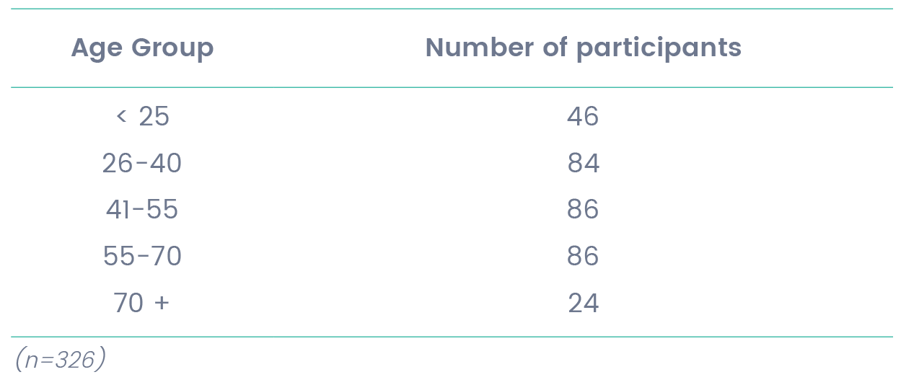

Respondents identified with a diverse range of disabilities with the most common factor being Mobility (75%), followed by Fatigue (43%). Factors affected by disability are summarised in figure 1. Interestingly, on average, people identified as having at least two factors affected by disability (m=2.13). This suggests that the impact of a person’s disability on their experience of using public transport can be complex and multifactorial. For example, an individual who is deaf may also have difficulty with verbal communication or a person may have multiple disabilities.
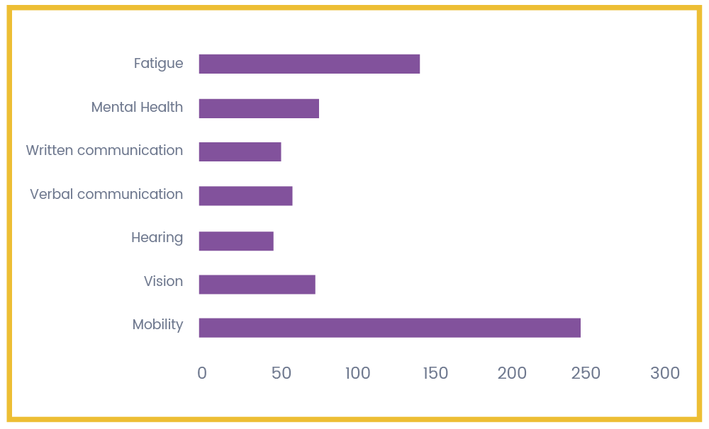

Figure 1. Factors affected by disability (n=335)

16% of participants indicated that they used a communication device, 45% used either motorised wheelchairs, manual wheelchairs or scooters and 5% travelled with an assistance animal.

The survey participants represented a broad reach of locations with 63% of respondents living in Metropolitan Melbourne and 37% in regional and rural areas (table 2). Participants in the project were from far flung parts of the state including Swan Hill, Bairnsdale, Warnambool and Wangaratta as well as inner and outer metropolitan areas of Victoria.

Table 2. Percentage of survey respondents by region

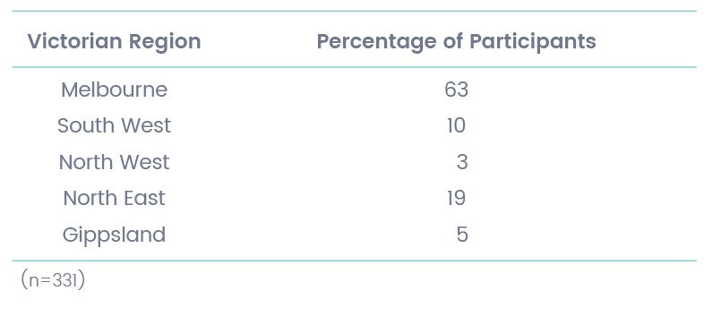

Finally, 62% of survey participants indicated that they used public transport on a regular basis (three or more times per week). Figure 2 displays the percentage of respondents who use different types of transport on a regular basis. The most common forms of public transport were by train (52%) and being driven by someone else in a private vehicle (50.5%). Commercial Passenger Vehicle services were used regularly by 44% of respondents with 57% indicating that they had a Multi Purpose Taxi Program (MPTP) card that provides discounted fares.

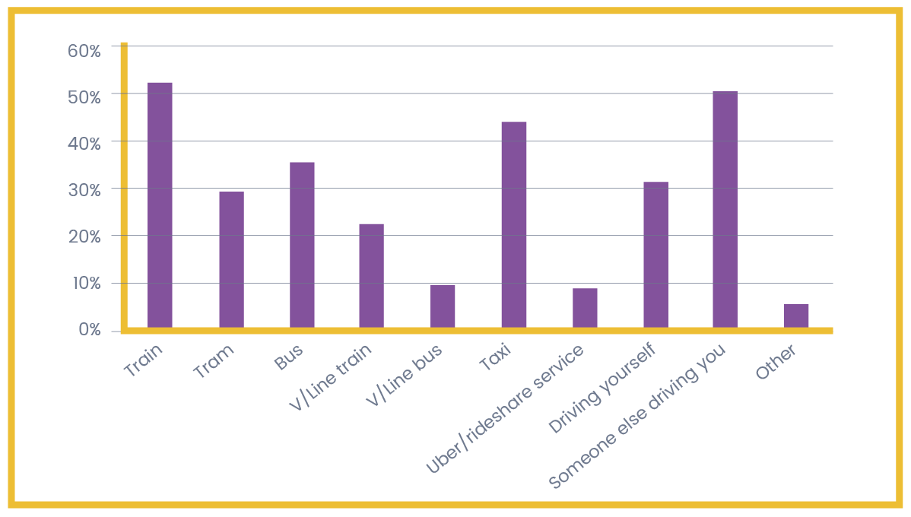

Figure 2. Types of transport used regularly (n=305)

38% of respondents indicated that they do not use public transport regularly. When asked why they did not use public transport more often, the responses were highly variable but included reasons such as:

- Lack of confidence using public transport
- No public transport available
- Time consuming
- Feeling unsafe on public transport
- Inaccessible public transport
- Prefer to drive

Forums

Two initial focus groups were held early in the project, one in Melbourne and one in the Macedon Ranges, to gather information about potential themes, to assist with developing meaningful questions, and to evaluate the role facilitators would play in the forums.

There were five public forums held; Melbourne, Dandenong, Ballarat, Sale and Shepparton. In total, 133 individuals participated in forums and focus groups (female=88, male=44, nonbinary=1). The ages of forum attendants was not collected, however, it was generally observed that there were a smaller proportion of participants in the 18-40 age group compared to those 41 years and over. This may reflect a preference of many young people to engage online and via social media or that forums were held during business hours and may have excluded people who are engaged in the workforce or study. Similar to the online survey, participants represented a variety of factors affected by disability including people with vision impairment, wheelchair users, those living with chronic illness and those with communication difficulties. There was however, a significantly lower proportion of people who identified as deaf attending the forums (n=1) compared with the online survey (n=50). These differences again demonstrate the benefit of offering different modes of consultation.

It was also observed that forum participants had attended with a desire to help make their communities more accessible, rather than merely coming to air their grievances, and that they were prepared to be involved in creating solutions. There was a strong consensus between forum members on what the main issues were in their local areas and this was particularly evident in the regional forums. For example, the residents of Ballarat were in agreement that the new train station was an opportunity to improve pedestrian rail crossings and access to the bus terminal. Likewise, residents in Sale understood that bus routes, that had not been updated in several years, did not adequately service new housing estates nor did they connect people with the cultural centre and library. Individuals at all forums were encouraged to raise their personal concerns and participants were generally supportive of each other’s right to be heard and respected. An additional benefit of these forums was that it brought people together who have a common interest in making public transport more accessible and there is great potential for local advocacy to be furthered through these connections.

The forums also provided an opportunity for local advocates, Councillors, V/Line staff, community transport operators and Members of Parliament to engage with and listen to people with disabilities speaking about their experiences using transport. These key stakeholders reported that attendance at the forums raised their awareness and understanding of the unique barriers for people with different disabilities in their communities.

Interviews

One-on-one interviews allowed for deeper discussion of the issues facing Victorians with disabilities on an individual level. These conversations gave participants opportunity to elaborate on public transport barriers most significant to them and to offer possible solutions to be considered. Time was also given to reflect on what services worked well and the resulting benefits that can be experienced when transport is accessible. These vignettes provided an insight into the very real impact and toll of an inaccessible public transport system on the lives and opportunities of Victorians with disabilities, as well as constructive feedback of ways it can be improved.
Analysis of Findings
Consistent themes and issues emerged throughout the consultation, with many commonalities of shared experience across the state. These themes reflected most areas of travel including safety, staff and public conduct, accessibility of information, infrastructure and vehicles. There were also issues identified that were unique to regional and rural areas such as choice of transport options and lack of accessible services.

Key factors affecting accessibility

Accurate, Accessible Information

An issue of particular importance for the independent travel of those with hearing or vision impairments. There were a variety of instances where audio and visual information is either absent or could be improved. One blind participant explained that when alighting the train at an unfamiliar stop they are not always confident that they have the correct station or what side of the train to exit. When the audio correctly announces the next station this is adequate, however sometimes it is delayed or incorrect. Another individual described an experience of waiting at the door until the train came to a stop and, upon realising they were on the wrong side, needed to navigate to the opposite door before the train doors locked.

Audible announcements of the next stop are available on some trains, trams and buses but not all. People indicated that sometimes they know that buses have the technology to make audio announcements, but they are either turned off or not working.

Priority seating

Lack of seating at stations, stops and on public transport was commonly reported by individuals who have difficulty standing and therefore require a seat. Examples were given of other passengers refusing to make priority seats available when asked and, as a result, the person with disabilities had experienced anxiety and discomfort. Whilst this was a common issue for participants with ‘invisible’ disability, those who used mobility aids also had similar experiences. In some cases, this led people to travel outside peak times or to avoid public transport altogether.

“Having ‘invisible’ illnesses as a young woman means that using or getting a disability seat on trains is difficult and I am often judged for using them whilst looking ‘healthy’. I have been turned down by people for asking for a seat on packed trams and trains resulting in me sitting on the floor which is incredibly humiliating hence why I avoid public transport (which means my independence is greatly reduced).”

Public Attitudes and Personal Safety

There were reports of harassment and abuse in the survey responses, particularly from women and nonbinary respondents. 61% indicated that they felt vulnerable or unsafe when using public transport and 44% reported experiencing verbal abuse, physical violence or intimidating behaviour whilst using public transport and commercial passenger vehicles (taxis and rideshare).
Many people with mobility impairments who do not use a mobility aid referred to themselves as having an ‘invisible’ disability. Participants reported that they felt judgement from transport staff and members of the public, which sometimes triggered altercations, verbal abuse, refusal to vacate priority seats or to provide accessible services. This caused significant anxiety and tended to result in avoidance of certain modes of transport and/or peak hour travel.

Survey participants were invited to elaborate on why they felt vulnerable or unsafe on public transport and the responses separated into two streams;

Feeling vulnerable due to the behaviour of other people,

- Other passengers’ behaviour due to being intoxicated or having mental health issues
  - Walking to or from public transport, especially at night and through isolated tunnels
  - Relying on others to help swipe Myki or handle money to pay fares
  - Feeling unable to physically defend oneself
  - When bus or CPV drivers are unsafe on the road

- Personal safety when navigating physical spaces.
  - Overcrowding and lack of seating
  - Being unfamiliar with a station or stop
  - When the CPV driver does not strap passenger in sufficiently
  - Lack of lighting at stations and stops

For some individuals, concern about personal safety was cited as a reason to avoid using particular modes of transport.

Staff conduct

There were reports of inappropriate behaviour from public transport staff including bus, train, tram and commercial passenger vehicle (CPV) drivers, Protective Services Officers (PSOs), conductors and customer service staff. Individuals have experienced sexual misconduct from CPV drivers, including sexual assault and offers to exchange sexual intercourse for CPV services. There were instances of transport staff treating people with disabilities with contempt, such as train and bus drivers expressing frustration or aggression when assisting with ramps and staff suggesting a person does not look disabled and therefore was not deserving of assistance. Participants also reported being accused of being intoxicated, particularly those with intellectual disability or an Acquired Brain Injury, when seeking assistance.

Contrary to these experiences, it is noted that individuals also shared positive examples of empathetic and exemplary service from transport staff whilst using public transport. Several people expressed appreciation for bus and CPV drivers who provided reliable, caring and thoughtful assistance, particularly in rural areas, where drivers have developed an understanding of the requirements of their regular passengers. The behavior of such operators has a knock on effect, not only reducing anxiety about public transport use, but fostering an attitude of inclusion and human value. It could be as simple as people feeling assured that the transport will arrive on time or that a bus driver would wait for passengers to be seated before taking off. Several participants reported that having the direct contact details for their preferred CPV drivers helped to develop trust, confidence in their reliability and a sense of safety.

“On one occasion a female tram driver got out of her cab, lifted my bag onto the tram and did it with a smile. And I did use to enjoy the rare occasions Bruce drove the trams in Bridge Rd with his unique, humorous commentary. Bruce created an extraordinary atmosphere of goodwill through his humour.”

Community Consultation

Concerns were raised at the forums that there was little known about opportunities that exist for people with disabilities to provide feedback about transport accessibility issues. At the Ballarat, Shepparton and Sale forums, there was a sense that people with disabilities were recruited to give feedback through community forums, however that plans were already in place and there was very little willingness to take on feedback or improve accessibility. Throughout the project people communicated that their feedback is ignored, despite their efforts to voice their transport accessibility concerns to the relevant bodies.

One exception to this was identified in relation to the recent consultation process for the new High Capacity Metro Trains in Melbourne. This consultation was reported to be more constructive, resulting in many additional accessibility and safety features.

Bus Safety

Bus safety was a concern across all forms of consultation. There was a general consensus that bus travel can be risky for those who use wheelchairs or have other mobility impairments. For example, narrow ramps, which are particularly dangerous when buses stop outside the designated accessible area, can be difficult to navigate or simply too steep. Once onboard, wheelchair users reported difficulty with the small turning circle inside the bus and the general struggle to get into a safe position. Instances were reported of bus drivers taking off before passengers are seated or wheelchairs are in a safe position and of accelerating, braking and taking corners very quickly, resulting in injuries both to wheelchair users and those with mobility impairments.

In a large regional town, one forum participant disclosed an incident where a bus driver took control of their wheelchair without consent, causing them long term injury. In addition, people with no or low vision highlighted a lack of audible announcements on buses, or audible announcements that are out of order making people uncertain of getting off at the correct location.

Tram access

Tram access was a concern to both those who live in areas serviced by trams and those visiting Melbourne from rural and regional areas. The most common issue raised was for people who could not board with wheelchairs, scooters or other mobility aids. Whilst there are several accessible trams stops throughout Melbourne, the majority are not accessible, even when the route is serviced with low floor trams. There were several reports of people being able to board a tram at one stop, but not able to exit the tram at their preferred destination, resulting in the tram user having to remain on the tram to the end of the route and return to their original tram stop. Participants at the Melbourne forum identified that this uncertainty about which trams are accessible is exacerbated by unreliable information displayed at tram stops and the lack of notification when a scheduled low floor tram has been cancelled. The absence of audible announcements or inaccurate announcements were a problem for people with vision loss and tram destination displays could also be difficult to read.
Pre-planning the journey is the first stage identified in the Whole Journey guide and these issues make it very difficult to plan in advance when relying on tram travel.
At the Melbourne forum, participants spoke of the great potential for the whole community, including the elderly, travellers with children or luggage, pram or shopping buggy users as well as people with a temporary condition, to access the city efficiently if trams and tram stops were made fully accessible. This would be a benefit for everyone, not just people with a disability.

Access to train platforms

It was identified, both in the survey and during the Metropolitan forums, that a number of metropolitan train stations have a single elevator as the only accessible way to gain entry to the platform. In the event that these elevators break down, passengers with mobility impairments are left stranded on the platform or need to travel to a nearby station and find an alternative way to travel. Participants in several forums and survey respondents highlighted that some rural, regional and metropolitan train station platforms are only accessible via very steep ramps that were prohibitive for some people, particularly wheelchair users.
“The train ramp to the station is perilously steep in too many suburban stations. The train takes me longer to get off, so if the driver gets impatient I have to travel to the next stop then turn around and come back (up and down those terrifying ramps). How come railways, a public facility if ever there was one, can get away with ramps whose gradients are so far off the building standard scale as to be a real risk?”

Independent boarding

Positive feedback was received regarding the upgraded train stations which allow independent boarding for wheelchair and scooter users on some trains. There was a desire to see these services expanded across the network in a timely manner to enable independent access for all train users.
Similarly, the feedback for accessible trams that allow independent boarding was very positive when they were available and the traveller was confident that their destination stop would be accessible. This is a fantastic example of independent and inclusive transport.

Accessible Car Parking

Those who used trains reported a lack of accessible car parking spaces at stations across metropolitan, rural and regional Victoria. Some reported that, as there was no public transport from home to the station, being unable to park meant that the train was not accessible.

Commercial Passenger Vehicles (taxis and rideshare)

Feedback from participants about the Commercial Passenger Vehicle (CPV) industry was limited to taxis and Uber (both booked and unbooked). An issue raised at the forums, in the survey and in 1:1 interviews was the unreliability of CPVs. People reported that they depend on CPVs either as their sole means of transport, or to connect them with other modes of public transport. It is common for vehicles to either arrive very late, or to not turn up at all resulting in individuals missing appointments, social activities or not being able to access public transport. This was reported to be a significant anxiety for people, particularly those who live in areas not serviced by rideshare options, those who cannot or do not use a smartphone and those who require a Wheelchair Accessible Vehicle (WAV). Not one participant reported using Uber Assist as vehicles were not available when they needed it.
There was concern by individuals who do not or cannot use smart phones, that rideshare models such as Uber would crowd out traditional taxi services, and they would no longer be able to access the services they require. In addition, participants reported that drivers did not like short local fares, and as a consequence, would not arrive at all. Rideshare services such as Uber do not accept the Multi Purpose Taxi Program (MPTP) card which makes it inaccessible. Companion dogs were also a problem, with drivers not stopping or taking off before the customer could get into the car.

As noted earlier, it was common for people to have identified local CPV drivers who are reliable, understanding of their needs and they can trust. This service is particularly important for people who have lost confidence in using other forms of public transport, however there is a significant cost impact for those on low incomes.

Unique rural and regional issues

While there were many common experiences for people living in rural, regional and metropolitan areas, these issues were often exacerbated for people with disabilities living in regional and rural areas due to lack of services or alternative transport options. The experiences of living in a regional town was also found to be vastly different to the experiences of those living in more remote locations. At the regional forums, it was identified that transport options seem to focus on getting to and from Melbourne. For those in more remote areas the priority was transport to get to their local towns, between towns and on occasion to larger regional towns and for many in remote areas, public transport is non existent.

-
Case Study: Charlene

Charlene lives in a regional town, uses an electric wheelchair and regularly travels to access the library, restaurants, shops, community events and the local hospital. Charlene also travels into Melbourne for specialist doctor appointments as well as visiting friends and family. In Charlene’s words;

“There are two accessible taxis in my area. You either have long wait times or, even when you have booked, it doesn’t show up. It’s pot luck. Also, the expectation is that everyone has a MPTP card, I don’t so it’s very expensive. Getting into the back of a Maxi Taxi is always invasive. You feel vulnerable and have no control as they strap you in.

I am not far from the shopping precinct, but there is no accessible path between my home and the shops. I am told that this is happening, and whilst parts of the path have been completed, they don’t connect and no one can tell me if or when this will happen. There is no feedback to the community. It is only that I am angry that I can’t leave my house that I make calls to find out.”

Charlene says that if public transport was fully accessible she could have an independent life of her choosing; to shop when she likes, go to the library for as long as she likes or simply to have coffee, rather than prioritising her travel for medical appointments.

“In a perfect world public transport is completely reliable. Buses go out to areas that are not currently serviced, are always accessible so I don’t have to pick and choose when to travel, and all drivers know how to use the ramps. Staff are trained to be respectful and treat people with dignity – not talking down to people. Where the default on all trains is to have accessible toilets on accessible carriages, especially on long haul rides, and that there are more than two spots for wheelchairs as people like to travel with their friends. Being able to decide on the day and know you can get on the bus, train or taxi just for the pleasure of travel. I could then be spontaneous, have choice and freedom.”
-
Due to the limited services, it was common for people to report that accessible local buses are only available for use for a short period in the late morning and early afternoon as they are prioritised for local school transport. This was reported to limit opportunities for work and study.

At the Ballarat, Sale and Shepparton forums, participants raised concerns that there are not enough Commercial Passenger Vehicle (MPV) services available to cater for the whole community. If one vehicle is employed for a long trip, for example to Melbourne, it limits access to services for the rest of the town during that period, even if they have booked well in advance.

Travellers Aid

There was an overwhelmingly positive response to the services of Travellers Aid, with many requests to expand the service to outer metropolitan and regional locations. In particular, participants in the Ballarat, Shepparton and Sale forums identified that people travel from rural areas to regional centres to access healthcare and other services, visit friends and participate in broader community life. They suggested that Travellers Aid would be valuable in key regional areas.

Impacts

The impact of transport accessibility barriers on communities across Victoria was significant. Participants reported that inaccessible transport is a barrier to employment opportunities, study opportunities, social inclusion, community engagement and general independence. Many people commented that previous experiences with, or attempts to use, public transport and Commercial Passenger Vehicles lead them to avoid the services where possible, increasing their social isolation. When responding to the online survey, 63.1% of individuals reported that they feel stressed or anxious when accessing transport services.

Forum participants were asked, “If public transport was fully accessible, what kinds of things would you do that you cannot do now?” Participants commonly responded that it would increase their independence, freedom and ability to experience life in a similar way to the rest of the community.

In the online survey, 67.24% of people responded that transport barriers lead them to miss out on doing things they would like to do.

Conclusion

The DRC consulted with more than 450 individuals with disabilities throughout Victoria in the latter part of 2017 through to May 2018. Participants in these consultations represented a diverse range of disabilities, age groupings and metropolitan, regional and rural locations within the state.

Using forums, an online survey and one to one interviews, individuals were asked to share their lived experience of Victoria’s public transport system and Commercial Passenger Vehicles (taxis and rideshare). The objectives of the project were to identify what worked or did not work, what improvements could be made and what impact accessibility, or the lack of accessibility, had on people’s lives. Participants responded with goodwill, honesty and a genuine desire to be involved in creating solutions.

As many people noted, an affordable and accessible public transport system was integral to their independence and the extent to which they could pursue the opportunities many others in the community took for granted. This included study, work, recreation and social and civic participation. People were quick to point out the benefits of an accessible public transport system for many others in the community including those who are elderly, travelling with children or luggage, pram and shopping buggy users and those with temporary conditions, as well as people with disabilities.

Some individuals negotiated various or particular modes of transport with little difficulty. Accurate and accessible information contributed to effective pre-journey planning for some. For others, any difficulties they may have anticipated, were able to be addressed because of the respect and quality service provided by staff. In rural areas this was commonly particular bus or Commercial Passenger Vehicle drivers who the person had come to trust. In addition, those who had experienced independent boarding on trains or trams at accessible stations or stops valued this highly. However, this was not the experience of many who shared their stories.

There were multiple factors cited by participants about what was not working in the public transport system. These could generally be classified as a lack of genuine consultation with people with disabilities, attitudinal and behavioural problems of staff and/or the public, physical barriers including inadequate and inaccessible information systems, a lack of planning and public amenity and an absence of continuous quality improvement monitoring and review. The majority of respondents who faced challenges in the public transport system often experienced more than one of these barriers to a safe, accessible journey.

The findings of this report indicate that there is still considerable work to be done to develop an accessible system of public transport in Victoria. The Transport for All report asks planners, engineers, providers, government funders and others to see the journey through the eyes of the traveller; that is the individual with disabilities. This report has consulted widely to capture and share the experiences, both positive and negative, of the public transport system through the eyes of Victorians with a disability and to identify strategies to move to a fully accessible public transport system.

Recommendations

Issue: Lack of genuine consultation with people with disabilities

It was identified that there was little known about opportunities for people with disabilities to provide feedback about transport accessibility issues. There was a general sense that when people were recruited to give feedback to transport providers there was little willingness to follow through on suggestions to improve accessibility. When changes and upgrades are being considered relating to modes of transport and related facilities, consultation with people with disabilities must be a priority.

Recommendations:

1. The Public Transport Access Committee (PTAC) include regular representation by key Disability Advocacy Groups who have the opportunity to advise the Minister on Public Transport accessibility matters.

2. Public Transport Victoria and Commercial Passenger Vehicles Victoria establish a program of ongoing consultation with people with disabilities and key disability advocacy organisations to plan, implement and review the development of accessible public transport in Victoria.

3. In consulting with people with disabilities, multi modes of engagement and communication are utilised to enable meaningful participation.

Issue: Lack of awareness of disability by both public transport operators and the general public

There were repeated examples of ignorant, discriminatory or abusive behaviour by staff or members of the public reported during consultations across different settings and modes of transport within the state. This often culminated in a denial of some aspect of service such as assistance or priority seating, varying degrees of public humiliation and increasingly, anxiety and fears for personal safety. Poorly trained staff or providers were also cited as presenting a risk of physical injury to travellers with disabilities. Several respondents had experienced injuries due to the unsafe handling or driving practices of providers.

Recommendations:

4. In collaboration with a key disability resource and training organisation, a comprehensive disability education and training program be developed for all public transport providers in Victoria. Successful completion of this training should be a pre-requisite for all staff prior to any roles and responsibilities related to working with the public.

5. 100% completion of the disability education and training program for all staff dealing with the public becomes a Key Performance Indicator (KPI) for government public transport provider contracts and an ongoing registration requirement for Commercial Vehicle Provider operators.

6. A multi-media community education program be conducted to raise awareness about the diverse nature of disability, the critical role of accessible public transport for the study, work and life aspirations of people with disabilities, and to highlight the key components of accessibility in daily public transport.

Issue: Barriers to public transport due to the built environment

For others the barriers were in the surrounding built environment, from the start to end of their journey including, for example, a lack of adequate disability car parking at train stations or poor street lighting or inaccessible stops or stations. For others, the disjointed nature of the public transport system made travel impossible; for example, a low floor tram, but no accessible tram stop or cancellation of a disability accessible bus for the return leg of the journey. For those with vision loss it was a lack of audible announcements and difficulty reading destination signage on transport.

Recommendation:

7. The Victorian Government develop and publish its forward plan detailing the steps, key milestones, timelines and key performance indicators to deliver a fully accessible public transport system which complies with the DSAPT by 2032.

Issue: Inadequate response to concerns and complaints

When the system had failed, people with disabilities recounted their attempts at raising their concerns or complaints, but reported that it appeared to have little if any impact. This perceived lack of accountability contributed to concerns about whether their needs and rights were valued by some public transport providers.

Recommendation:

8. A Public Transport Feedback and Complaints Register (PTFCR) for all modes of public transport be established to promote accountability, transparency and continuous quality improvement. The PTFCR be managed by the Public Transport Ombudsman and include the production of annual audit reports identifying the nature and category of complaints, and the outcome and timeline for resolution of all complaints.

Disability Resources Centre Inc.
Level 3
247 Flinders Lane
Melbourne
Victoria 3000

www.drc.org.au

For enquiries 03 9671 3000

United Nations, Convention on the Rights of Persons with Disabilities, 2006.
Australian Government, Review of the Disability Standards for Accessible Public Transport 2002; Draft Report, May 2014.
Australian Government, National Disability Strategy 2010-2020, 2011.
Australian Government, Disability Discrimination Act 1992.
Victorian Government, State Disability Plan Absolutely Everyone, 2016, p.24.
Victorian Human Rights and Equal Opportunity Commission, Disability and Transport, webpage 2018.
Victorian Department of Transport, Transport Standards Submission 93, 2012.
Transport for Victoria, Accessible Public Transport Action Plan 2013-2017, webpage 2018.
Australian Government, The Whole Journey – A guide to thinking beyond compliance to create accessible public transport journeys, 2017.
United Nations, Convention on the Rights of Persons with Disabilities, 2006
Australian Government, National Disability Standards for Accessible Public Transport, 2002.
Australian Government, The Whole Journey – A guide to thinking beyond compliance to create accessible public transport journeys, 2017.
United Nations, Convention on the Rights of Persons with Disabilities, 2006.
Australian Government, Disability Discrimination Act 1992
Australian Government, National Disability Strategy 2010-2020, 2011.
Victorian Government, State Disability Plan Absolutely Everyone, 2016, p.24.
Victorian Human Rights and Equal Opportunity Commission, Disability and Transport, webpage 2018.
DRC, DAIS & VCOSS, Accessible Public Transport Watch Project, 2008.
Department of Infrastructure and Transport, Review of the Disability Standards for Accessible Public Transport 2002; Draft Report, May 2014
Victorian Department of Transport, Transport Standards Submission 93, 2012.
Price Waterhouse Coopers, Disability expectations – Investing in a better life, a stronger Australia, 2011.
Case study from 1:1 interview. The individual’s name has been changed to protect their privacy.

