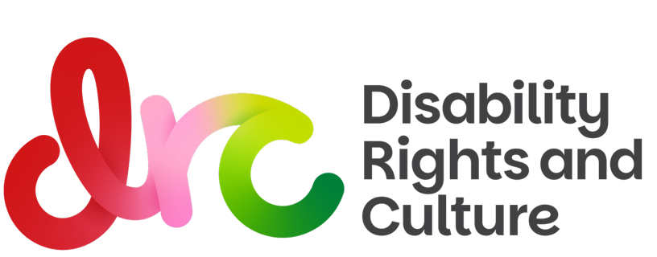

BELONG INDUCTION WORKSHOP – LOW ENERGY VERSION

Hello, and welcome to Belong!

We know not everyone has the capacity or energy to attend a full induction workshop to join Belong—which is why we’ve created this written version. Now, you can get all the goodness of an induction, with less spoons!

Why do we have an induction, anyway?

As a disability rights organisation, we want to make sure everyone in our group feels safe and supported. We are creating a space for those in the disability and chronic illness communities—a space where we are all welcome, no matter our differences.

Our values

To make our community a safe space, we have some guidelines. This includes:
    - We attend with openness, honesty, respect and kindness
    - Confidentiality is essential
    - We are committed to equality for all
    - We celebrate diversity of disability, ethnicity, culture, gender, sexuality, age and race
    - We practice deep listening without judgement
    - We listen to validate, not to fix
    - We acknowledge and thank those who share
    - We give one another permission to be inarticulate

It’s important that we remain open and willing to learn, and change if necessary. We hold our beliefs lightly, and recognise everyone has different experiences.

However, there is no space for any kind of racism, queerphobia, transphobia, ableist or ageist behaviour in our groups. Everybody belongs: and we all deserve kindness and respect.

About Belong

Belong is a community of over 170 people with disability and chronic illness: but our goal is for every person with disability in Australia to join our community.
It’s a space by us, for us. It includes groups with both online and in-person options, as well as events, like our Disability Pride Month Celebration every July.
Belong was created to bring the disability community together – because historically, we’ve been quite fragmented. There are many barriers for us to meet and connect with each other, which is why Belong was created.

Belong is a unique, supportive peer-to-peer space where disabled people can be themselves. We can share our knowledge, our experiences, find friends and community, and work together as we battle for equality. This group is exclusively for those who identify as part of the disability community. This includes those in the chronic illness and neurodivergent community, as well as those from the Blind and d/Deaf community. We are radically inclusive: you don’t need a diagnosis to join. And there are no families or carers here, unless they also identify as disabled.

While it’s run by the DRC (Disability Rights and Culture), our disability network belongs to its members. We shape how it’s run together—and we can grow it together.

Our meetings and groups

Our vision is to connect all people with disability. We have several options for both online and in-person participation: but we’re also very welcome to your suggestions! Have an idea? We’d love to hear it!

Most of our groups have an agenda with specific topics, while others are informal catch ups. All meetings are facilitated. We accept all forms of participation and communication—camera on, camera off, communicating by speaking, by chat, by AAC. And we make sure we have captions turned on, and can organise interpreters. If we can do anything to make things more accessible for you, please let us know!

Want to join? Our Communications and Engagement Coordinator Finnley Greet will send you an email with the calendar, schedule and more information about the groups after this induction.

Got questions? Email us at belong@drc.org.au

About Medical Mates

We know navigating the healthcare system can be hard, scary, and even traumatic: especially when your experiences aren’t heard or believed. This is why we created Medical Mates. It includes:

- Before and after de-briefs where you can chat through your experiences with community who get it
- Medical Mates Companions: need someone by your side? We can get someone to join you for your appointment to support you, take notes, back you up, or sit quietly in solidarity
- Workshops on medical gaslighting where we show up, support each other, and build tools, confidence and collective care

Let’s reclaim power in medical spaces: together.

So, what’s the Belong difference?

It’s a place by us, for us—and we want to make sure everyone has a great experience. We can do this by:

- Deep listening: we listen to each other with patience, understanding, and without judgement
- Making sure someone feels heard: When we listen, people know they aren’t alone. We want everyone too feel acknowledged, appreciated, included, and like they’re being taken seriously
- Different experiences: we all have different experiences and views, and all are valid. We navigate them with respect and curiosity
- Championing radical access and inclusion: accessibility is more than just ramps or captions or braille: it’s about making space for all disabilities and all intersectional identities. Access is love, equality, inclusion and care
- We reject ableism and non-disabled expectations: you are welcome, in whatever way you can participate. You can have your camera off, communicate via chat, get up, move around, lie down, fidget, not make eye contact, or anything that makes your experience more accessible
- Recognising competing needs: sometimes, accessibility needs can clash. We’re committed to accommodating individual needs, and doing what is best for the group
- Prioritising safety and authenticity: you can be whole self in Belong.
- Respecting boundaries: we all deserve to feel comfortable and safe. It’s a good idea to check in with the group before sharing something that could be triggering, and to check in with yourself if you’re uncomfortable. We are here to support you
- We don’t talk over each other: we take the time to think, and ensure everyone has the time they need

Remember: we are all learning, all the time—and we are all in this together. Kindness is healing in times of trouble, and listening is one of the most therapeutic acts of kindness one can perform. It’s a gift we can give each other.
About facilitation
All our groups are facilitated by volunteers who are members of our community. All facilitators will be trained, so they can effectively hold space for others. It can be a great feeling of purpose and connection to give back to community. If you’re interested in becoming a facilitator, please get in touch: we would love to have you.
Facilitators will start each meeting with a check-in, and make sure everyone is comfortable with the topic. We try to speak in rounds, so everyone gets a chance to be heard: but there is no pressure to share, either!
If you’re attending online and you’re feeling uncomfortable but can’t communicate through words, you can also press the “slow down” emoji on Zoom (which is a grey circle with two backwards arrows), or type “slow down” in the chat. The facilitator will then stop the conversation, and re-direct the group. If you request to slow down, we may pass your details to one of the Belong team members to ensure you’re okay: but there is no pressure for you to respond, and you can let us know if you’d prefer we don’t do this.
As group members, our facilitators deserve kindness and appreciation. We acknowledge them at the end of every meeting. If you’re feeling uncomfortable in the group at any time, please contact the facilitator – and if you’d like to take it further, please contact belong@drc.org.au or ally@drc.org.au. We value your feedback.
Practical info on Belong
We send weekly reminder emails every Monday about what’s going on in Belong, and also send a bi-monthly schedule so you know what’s on. We know life can get busy and exhausting, so there is never any pressure to attend.
Aside from meetings and events, we also have other ways you can get involved, including:
- Our What’s App Groups and Discord server
- Our Medical Mates and Mutual Aid programs
- Popping into the DRC in person for our fortnightly catch ups
- Writing for the Belong blog (it’s paid!)
If you’d like to talk to someone about getting involved with the Blog, please contact Zoe@drc.og.au
So, what now?
Once you’ve read through this document (or watched the recorded version), please email belong@drc.org.au or finnley@drc.org.au to let us know that you’re ready to be sent the schedule and calendars. You can also check it out on the Belong website page.
Now you’ve heard a little about Belong, it’s a good time to take a look at the different groups and our calendar and see if any resonate with you. If nothing fits, we’d love to hear from you! We’re always looking on ways to improve, expand and grow.
To keep up with updates, you can follow DRC on Facebook, Instagram and LinkedIn, and you can follow Belong on Instagram and Facebook.
Any questions? Ideas? Reach out to belong@drc.org.au

